eComX.org Whitepaper

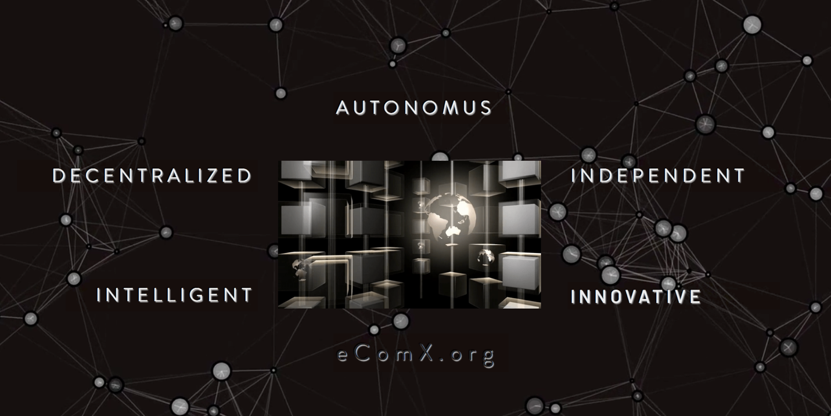

A Blockchain Platform for the crypto-ecommerce economy

eComX.org _ March 2018

Abstract 4

VISION 7

**The rise of the blockchain** 8

**The Internet of Values - IoA** 8

**Current internet of values problems to solve** 9

Introduction to eComX 12

**eComX and the Internet of Value** 12

**Understanding the “value” on the Internet of Value (IoA)** 13

**Current situation of the blockchain for the ecommerce economy** 14

**The eComX masterplan** 14

eComX Vision 15

eComX Architecture 15

**Key problems to be solved** 17

**Mission** 18

**eComX as an infrastructure platform** 18

**Architecture** 19

**eComX Interoperability solution** 21

**eComX Parallel Computing** 24

**Compatibility with Ethereum** 25

**Software Development tools and software library** 26

eComX Project Plan 27

**eComX Community Contribution** 27

**eComX community members** 28

**The importance of the eComX.org as a DAO** 28

Project Roadmap 29

eComX Team 33

Our Growing Community 36

eComX Products 37

**eComX World Marketplace www.eComX.world** 37

**eComX Dapp Store** 44

**eComX Blockchain** 45

**eComX Token** 45

eComX Token Distribution 48

TOKEN SALE - PHASE 1 48

TOKEN SALE - PHASE 2 48

TOKEN SALE - PHASE 3 49

MANAGEMENT AND ADVISORS RESERVES 49

PARTNERS PROGRAM 49

ANGELS & BROKERS (SPONSORS’ PROGRAM) 49

BOUNTY and AIRDROP RESERVES 49

FOUNDERS 49

RESERVED FOR MINERS REWARD PROGRAM 50

ECOMX USE OF FUNDS 51

TECHNOLOGY, SOFTWARE DEVELOPMENT, INFRASTRUCTURE 51

SALES & MARKETING 51

TEAM 51

CUSTOMER SUPPORT 52

LEGAL 52

ECOMX DAO ADMINISTRATION 52

OTHERS 52

DECLARATION 52

DISCLAIMER 54

# **Abstract**

Over the past several years, eCommerce has become a more centralized economy. An industry worth more than 22.1 trillion USD dominated by a handful of the world’s largest companies, such as Amazon, Alibaba, and eBay. Smaller shops are quickly getting crushed by their inability to compete against such formidable companies, and fast outdated with online shopping rapidly rising.

The strong hold control by a few, of such a giant economy, imposes a business model riddled with disadvantages for the consumers and merchants.

While these few conglomerates can be accredited for growing one of the most profitable industries, issues such as online fraud has reached unprecedented levels in recent years, merchants continue to experience unnecessarily high insertion and processing fees, which reduces profit margins. All these disadvantage small sellers. On the other side of the eCommerce spectrum are the buyers, they also are disadvantaged by this centralized model, as they are hit with added cost, tariffs, third party handling fees, and time delays.

Today we are beginning to witness the birth of the second internet revolution, “The Internet of Values”, which promises to do for ecommerce what the first wave of the Internet did for information. At the heart of this new wave, there exist a new technology infrastructure named “Blockchain” and it brings a new paradigm shift to humanity turning centralized business model into obsolescence, in the same way the cars brought it to horse carriages, and electricity did it for the industrial revolution.

No wonder that blockchain technology has been gaining in popularity. it provides mankind a brand new and efficient cooperation system. Blockchain’s application in the eCommerce sector has huge expectations. At present, all kinds of tokens have completed some basic functions of value transferring and value distributing, but it is still far from the fully addressing real-world issues presented by the current highly centralized model.

To bring about the era of the Internet of Value to eCommerce as soon as possible, we need a new generation of eCommerce infrastructure based on an expanded blockchain technology that can link different communities and which can bridge the gap between centralized and decentralized organizations.

Venture capitalist William Mougayar calls blockchain “the second significant overlay on the internet, just as the web was the first layer back in 1990”. When most people think of blockchain, Bitcoin instantly comes to mind. But the potential that excites Mougayar and many others goes far beyond ecommerce transactions made using digital currencies. It touches on what is called “the Internet of Value.”

**What is the Internet of Value?**

Like the Internet of Things is key on networking all things through intelligent networks, the Internet of Value is for value to be exchanged as quickly as information. Currently, although information moves around the world instantly, a single payment, for example, from one country to another is slow, expensive and unreliable. In the US, a typical international payment takes 3-5 days to settle, has an error rate of at least 5% and an average cost of $42. Worldwide, there are $180 trillion worth of cross-border payments made every year, with a combined cost of more than $1.7 trillion a year. The same goes for eCommerce, it is nearly impossible to purchase an item in a local store somewhere overseas without running into logistics, fulfillment, and payment issues.

With the Internet of Value, a value transaction can happen instantly, just as people have been sharing words, images and videos online for decades. The Internet of Value enables the exchange of any asset that is of value to someone, including merchandise, music, tickets, and many more.

**Blockchain enables value exchange**

Until now, selling, buying or exchanging assets has required an intermediary like a bank, marketplace (physical or digital), credit card company, or third-party booking service like Airbnb. Blockchain technology, including eComX.org’s solution, allows assets to be transferred from one party directly to another, with no middleman. The transfer is validated, permanent, and completed instantly. At last value will be able to move around the world as information does.

Investment management service, Rathbones [summarizes this potential](https://www.rathbones.com/knowledge-and-insight/blockchain-internet-value) as:

“…promising to do for value what the internet has done for information: decentralized control, remove asymmetries, and change the way we transact and interact with everything. From shopping and music downloading to collaborating and sharing of resources, blockchain promises to enable, empower and revolutionize. And disrupt.”

We’re already seeing significant applications of blockchain in the real world. [Nasdaq is using it](https://www.forbes.com/sites/laurashin/2017/02/21/why-nasdaq-is-even-more-optimistic-about-blockchain-than-it-was-3-years-ago/#561300701a26) to help firms manage shares. The Baltic nation of Estonia is [securely storing the healthcare records](http://pwc.blogs.com/health_matters/2017/03/estonia-prescribes-blockchain-for-healthcare-data-security.html) for more than one million of its citizens on distributed databases, Japanese airline Peach Aviation recently became the third commercial carrier to [accept cryptocurrency as payment for flights](https://www.ft.com/content/a0389242-3ee4-11e7-9d56-25f963e998b2), while the musician Imogen Heap built her own blockchain to [release a single directly to her fanbase.](https://www.theguardian.com/music/2015/sep/06/imogen-heap-saviour-of-music-industry)

For the Internet of Value to gain speed, it is critical to offer the ability for centralized value to be acted by smart contracts in a blockchain and as equally important, is to have Cross-Chain Inter-Operability.

At the moment, there exists a multitude of competing blockchains which do not necessarily connect with one another, so value cannot be exchanged like information just yet. For the internet of value to become a reality, industry standards must be adopted and a mechanism to allow inter-operability must exist.

This I why eComX.org is teaming up with a growing community of interested partners such as major marketplaces, ecommerce institutions, payment providers, logistics & fulfillment businesses to make the eComX blockchain network, the answer to the Internet of Value Paradigm for eCommerce.

With eComX, it is possible for value – to be exchanged in a trustful, immutable infrastructure.

**eComX vision for the second era of the internet**

At eComX, making cross-border purchases with a variety of currencies, performing payments faster, cheaper, and more reliable, lowering the cost of acquisition to consumers, making marketplaces cross-border enabled, allowing governments to participate as partners rather than regulators, while also introducing a standard protocol for how institutions and individuals connect across various networks to exchange data, are some of the benefits eComX is working on bringing to the Internet of Values.

We believe eComX has the potential to transform and impact our world comparable to the way the shipping container standardized commerce in the 1950s and drove globalization, or how the digital information economy has transformed our lives today.

We are preparing eComX for the crypto-ecommerce era! eComX will use EComX Tokens to wrap and transport value objects into the eComX blockchain where these EComX Tokens can fire events for other smart contracts to listen to and either execute instructions or inter-connect to other tokens to become packages of instructions to be processed by Xn nodes optimized for parallel computing.

We are also working to release “eComX World”, a cross-border marketplace to integrate fiat and crypto currencies, to connect centralized and decentralized eCommerce ecosystems through the use of a unique utility token ”eComX token” which acts as a transport wrapper technology to take centralized or cross-chain asset datasets into the eComX blockchain. it allows for on-chain requests and off-chain request to be operated by smart contracts within eComX by listening to their events as they are being fired.

eComX will transform eCommerce and redefines current time and place constraints, levied onto cross-border trade by actual centralize systems.

eComX will implement new eCommerce functionality which could deprecate many eCommerce services currently presented to merchants and buyers through costly subscription-based contracts.

eComX will be highly scalable. It is working on its own virtual machine, a Turing-completely VM which will provide infinite computational scalability for crypto-ecommerce to thrive, creating possibilities that were previously unimaginable.

This document represents the result of our analysis of the possibilities the Internet of Values can bring to eCommerce, and it puts forward the overall design, technologies, and development plan of the eComX project.

# **VISION**

Human cooperation based on markets that use currency as a medium of exchange has greatly contributed to human development, however, the lack of trust between any two people or any two social organizations has inevitably required that the current centralized ecommerce organizations to constantly address trust by using expensive added processes and technology to try to deal with this human issue. As a result, the cost of the traditional centralized market economy, due to the lack of trust, is high.

Currently, centralized ecommerce has become more and more concentrated in the hands of few people, thus creating a “single point of failure”. This means that a large amount of resources including power, capital, talents and data is being monopolized by these few ecommerce organizations.

### **The rise of the blockchain**

Up to this moment, we have lived in a world ruled by centralized systems controlled by a handful of individuals. These centralized systems have evolved and greatly contributed to the development of mankind. However, the model under which these centralized systems operate has reached its upper limits as it is no-longer enough to continue to patch it up with new expensive technology and pass alone the cost to consumers along the way.

Perhaps the answer is to find a way to better align the existing centralized ecommerce economy with a more efficient distributed market economy. This is a great undertaking, but our civilization deserves it and now expects it.

In such efforts, the distributed ledger technology represented by the blockchain may play an extremely important role in solving the trust problem of mankind. For the first time in human history, there exists a “machine of trust”. Blockchain represents a complete solution to the limiting issue of “Trust”, that is, to deliver trust to communities we need to establish various large distributed ledgers through various consensus mechanisms to solve conflicts in various human cooperation. Not only that, since ledgers are based on peer- to-peer networks, it makes peer-to-peer transactions and value transfers, automatic, irrefutable, and immutable contracts.

Thanks to blockchain, strangers not only can trade without first having to stablish a relationship of trust, but they can also automate their transactions through smart contracts.

Blockchain is the trust technology that will power the second internet revolution wave, the Internet of Values.

While most existing technologies mainly promote the progress of “productivity”, blockchains is reforming the way people cooperate. It is bringing about one of the greatest transformations to humanity, a new social model, a trust based global village driven by blockchains.

### **The Internet of Values - IoA**

Blockchain technology brings us from the age of the Internet of Information (IoI) also known as the first internet wave, to the age of the Internet of Values (IoV), which can be regarded as the second generation of Internet.

Because of the Internet of Information, the world has undergone tremendous changes. As a result of the Internet of Values, human society is bound to once again usher in enormous social changes. This is because the Internet of Values based on blockchain technology has the characteristics of digitization, intelligence, decentralization and inclusiveness.

Digitization and intelligence, which can bring efficiency to the Internet of Values are features that the Internet of Information already has, but are now being applied to the Internet of Values. A more essential characteristic is decentralization, which will help to completely solve the problem brought about by centralized organizations. The Internet of Values is also more inclusive and more prawned to cooperation.

When people easily send and receive information over the Internet people enter the age of Internet of Information; when they can easily process transactions and send value over the Internet and program value and execute transactions by smart contracts, they will enter the age of Internet of Values.

With time, ecommerce will process more and more transaction and transfer value on blockchains and entire ecommerce economies will be programmed with smart contracts in blockchains. As a consequence, people’s cooperation relations and human society will surely be greatly transformed.

Accenture’s report (2016) predicts that after an early exploration, blockchains will continue to grow between 2018 and 2024, when banks and ecommerce organizations begin to witness the benefits of early blockchain adopters, new government rules will also be gradually established, various new services and business models will begin to appear, and the original ecommerce business models will gradually be abandoned. After 2025, the application of blockchain will gradually mature, and the use of blockchain will become the mainstream, and at the same time it will be well integrated into the supply chain systems and into capital markets. The World Economic Forum’s Whitepaper “Realizing the Potential of Blockchain” (2017) boldly predicts that 10% of world GDP will be transacted on the blockchain network by 2027. It can be predicted, just as the early stage of the Internet of Information, that with the development of blockchain applications, the Internet of Values will gradually take shape.

### **Current internet of values problems to solve**

#### **Interoperability**

eCommerce is today a highly centralized economy, this means that most values exist in centralized organizations, data centers, and in different blockchains. The Internet of Values requires a seamless way for these assets to also circulate within a blockchain without requiring the entire data sets to be migrated to a distributed network and into one common blockchain.

#### **Scalability**

The second issue confronting IoA is scalability. The Internet of Values needs to be able to handle different areas of ecommerce, such as marketplaces, shipping, fulfillment, logistics, supply chain, payment gateways, inventory management, and government regulations. All these sectors hold a piece of data relevant to an economic transaction within ecommerce that must circulate freely within the internet of values blockchain and which will require some sort of processing or computing in order for the transaction to be successful. Multiply this by millions of transactions and you can imagine the issue of scalability becoming a bottleneck.

To solve these, we need to leverage the computational power of nodes through intelligent algorithms (POW & POS) in the blockchain network in order to perform parallel computational tasks, this requires the implementation of some sort of parallel event firing mechanism capable of grouping and sorting computational transactional requests by consensus type in order to maximize performance, and to deliver special regards to the computational nodes within the network to perform such computations.

#### **Usability**

The last aspect is usability. The Internet of Values needs to make available to developers the resources, software libraries, smart contracts, etc., with which developers can efficiently perform rapid software development and decentralized applications that users can easily use.

Currently, blockchains cannot interoperate with other blockchains (synchronization of state machines), tokens on different blockchains cannot trade with each other. Since currently blockchains cannot interoperate with outside centralized organizations, it makes off-chain assets difficult to be mapped on the chain. Since current blockchains cannot read off- chain data, it makes current blockchains’ “smart” contracts blind or dumb and cannot see or communicate with the outside world.

Taking cross-chain technology as an instance, cross-chain communication currently is extremely difficult, not to mention developing cross-chain smart contracts. At present, there are already thousands of tokens, but each token can only move freely on a single blockchain and form its own ecosystem of wallet, smart contract development tools, etc. The existing blockchain ecosystems actually are island ecosystems, and the Internet of Values is far from being truly interoperable.

As to scalability, while the Internet of Information is continuously expanding itself by encoding various information as bits and programming various scenarios’ communication logic as applications, the Internet of Values is just beginning to expand itself by tokenizing various values as tokens and mapping various scenarios’ transactions logic as smart contracts.

Due to the limited interoperability, the scalability of the Internet of Values is greatly affected. It is difficult to map the actual application scenarios involving multiple cross border transactions involving multiple currencies, multiple organizations and multiple data sources to a blockchain to form a distributed solution, which hinders the migration of off-chain values to the Internet of Values.

As to usability, while the computing power, storage capacity, and synchronous speed of the Internet of Information has been able to support most demands of information management, the Internet of Values can barely support slightly heavier projects. The Internet of Values has a lot of work to do in terms of standardization, platform development, functionality, application libraries, interoperability, and future malware attack protection.

Of the above three types of bottlenecks, interoperability is the most urgent and by enhancing interoperability, we can transfer values between different blockchains, program smart contracts with different tokens, and make update scalability more easily. Usability, however, is a long-term basic task, while interoperability and scalability, which have greatly hindered the development of the Internet of Values, are in-need of a short-term solution and have become the two most urgent bottlenecks to be solved.

##### **Current Interoperability efforts**

There are some insignificant attempts but cross-chain peer- to-peer value transfers and distributed solutions for cross-chain smart contracts have not yet emerged.

The side chain is the most important attempt of current cross-chain communication technology, but the communication between the main chain and the side chains is delayed, unsafe, and poor in synchronization and these problems are hard to solve. What is more, the interfaces between the main chain and the side chain in many projects are still centralized solutions. Efforts on cross-chain smart contracts may not be successful for a long time, since even the standardization of consensus of a single chain is far from mature, not to mention the consensus reached among multiple chains.

##### **Current Scalability Efforts**

Regarding scalability, it is still very difficult for a lot of off-chain transactions to be mapped on blockchains. Currently, ICO projects on public chains through protocols such as ERC20 are on the rise, but many ecommerce values, products, and assets, are still hard to map to blockchains as long as other aspects of the ecommerce work-flow such as shipment, logistics, fulfillment, just-in-time inventory assertion, etc. are also mapped.

##### **Current Usability Efforts**

In reference to usability, in the world of blockchains, technologies, parallel computing, high-throughput storage, cross-chain communications, programmability, interoperability, and software reusability, are still at their primary stage. There are some attempts to address these issues, such as solving problems through the private blockchains, or specifying only a few nodes to keep ledgers. But in the long run, it requires continuous efforts in hardware performance, algorithms, consensus mechanisms, cryptography and other aspects to improve the usability.

In short, interoperability, scalability, and usability are the major bottlenecks of the Internet of Values, but no good solution has yet emerged in the industry.

# **Introduction to eComX**

### **eComX and the Internet of Value**

The essence of the Internet of Values is to map various values to blockchains, so they can be controlled by smart contracts. The Internet of Values makes it possible for cooperation among people to be decentralized, disintermediated, inclusive, and programmable. These obvious advantages will make various values rush to be mapped to the blockchain. As the blockchain bottlenecks continue to be overcome, the Internet of Values will inevitably grow at a higher speed.

The process of values being mapped to blockchains requires abstracting the transactional logic from the business logic on each transaction. Initially, the Internet of Values was created with a strong ecommerce attribute. However, the concepts brought forward by IoA are also ideal for the ecommerce economy.

Since the Internet of Values is based on the Internet of Information, the Internet of Values contains most of the features of the Internet of Information. However, as far as information transmission is concerned, there is a notable difference between the Internet of Values and the Internet of Information: The Internet of Values is based on peer-to-peer networks using the User Datagram Protocol, which is why the Internet of Values has certain bottlenecks. In the future, the performance of the Internet of Values will gradually approximate the performance of Internet of Information, so that business scenarios and the ecommerce transactions involved can be seamlessly coded in the same program. However, judging from the current situation, we expect this will take a long time. The current Internet of Values will need a more flexible blockchain with parallel event firing and true parallel computing optimization using a fully Turing-Complete Virtual Machine with much more robust consensus mechanism.

### **Understanding the “value” on the Internet of Value (IoA)**

Before discussing what eComX does and how it can revolutionize the ecommerce economy, it is important for us to explain what the “value” in the Internet of Values is as it relates to ecommerce. We have already seen the profound impact of the Internet of Information on our lives. We can equally expect that the Internet of Values will bring about tremendous changes to our lives too. We may understand the types of information on the internet, but few discuss the “value” on the Internet of Values.

First, the values on the Internet of Values must, at a minimum, be tokenized to enter the blockchain, and at best, the values would exist as tokens circulating in a blockchain, and the process of mapping values to the Internet of Values is the process of tokenization of anything that can be bought and sold, traded, and transacted upon within ecommerce as it relates to IoA.

If the tokens on the blockchain represent the crypto-ecommerce transactions, then the digital data structure of the assets will be represented by a token, and at a minimum, it will be wrapped and encapsulated by a general-purpose token that can transport the digital data into the blockchain.

It is through this process that the Internet of Values allows more and more transactions to take place in the decentralized internet of values. making transactions with no intermediaries as easy as sending information and the programming of this type of transactions as easy as programming information, making the prospect of the Internet of Values similar to the prospect of the Internet of Information.

This prospect has already begun to emerge with the Ethereum when the ERC20 protocol came out, but Ethereum as a unifying blockchain for ecommerce is limited by its inherent lack of interoperability since it cannot communicate with centralized systems and act across blockchains and across external datasets. It also has limitation on scalability as the crypto-ecommerce chain of the future must be able to dynamically handle huge number of transactions a very high speed, similar to way the internet of information handles the transfer of information digitally.

Finally, the Values on the Internet of Values must become diverse for it to have a positive impact in ecommerce. In other words, if tokenization is profitable then, anything can be traded from a seller to a buyer, thus becoming a value in the internet of values.

We believe that a blockchain enhanced for ecommerce, a crypto-ecommerce blockchain that solves the issue of interoperability and that makes parallel computing a core scalability attribute, will accommodate most of the off-chain values currently transacted in existing marketplaces as more and more physical assets are represented digitally, assets such as houses, works of art, intelligence and other valuable thing, can also become tokenized or at a minimum wrapped by a specialty token, and then, they can enter into the blockchain for processing, transferring, and proper storage.

### **Current situation of the blockchain for the ecommerce economy**

Ecommerce activities that exist on the Internet of Values have just begun. Although some people think that blockchain for ecommerce using crypto currencies have taken off, their total value is miniscule in comparison to the 22.1 trillion USD which is the current size of the eCommerce economy. This is not even a drop in the bucket compared with the existing global ecommerce market scale.

### **The eComX masterplan**

First, we need to clarify that we do not expect a blockchain for the ecommerce economy will solve all the problems of centralization. Centralized organizations are important products of the evolution of human systems. They will co-exist with blockchain communities in the future and together promote the formation of the Internet of Values. The difference is that central organizations will become the main service provider of the decentralized services performed by the crypto-ecommerce blockchains.

While blockchains will become the infrastructure for the crypto-ecommerce economy, crypto-ecommerce will integrate all kinds of services and people into crypto-ecommerce activities. It is foreseeable that with the development of the crypto-ecommerce infrastructure, traditional ecommerce institutions will gradually be transformed into service providers for the surrounding services and ecommerce applications now possible with crypto-ecommerce.

The eComX blockchain will accommodate a wide range of values. This is why as part of the Internet of Values the eComX blockchain is all inclusive. eComX will not exclude all the values that can be mapped to its blockchain, and will not exclude all those people or centralized organizations who are willing to participate, and all of them will become part of the ecosystem of the Internet of Values.

eComX is being developed on the vision for an upgraded crypto-ecommerce system, a crypto-ecommerce built on the Internet of Values. While a large number of crypto-ecommerce applications can be abstracted from existing business scenarios and the requirement for the usability of the Internet of Values is not high, still, in order to create a masterplan for a truly comprehensive crypto-ecommerce, we need to address the issues of interoperability and scalability. In particular, we must solve the issue of interfacing centralized ecommerce with a decentralized ecommerce, and the issue of cross-chain data exchange, by developing new tokenized technology that can wrap objects irrelevant of their type (centralized, cross-chain, etc.) and transport them into the eComX blockchain for processing. Only then we can achieve a rich crypto-ecommerce economy.

# **eComX Vision**

Considering the bright future of crypto-ecommerce and the bottlenecks of the current Internet of Values, we propose the eComX project. The eComX vision is to establish a new enhanced public blockchain for the crypto-ecommerce era that contains all the key elements needed to conduct cross-border trade, and for value transfer, which can connect multiple smart contracts to provide complete ecommerce functionality (Buy/Sell/Shipping/Logistics/Inventory-Mngt/…. A bridge between centralized and decentralized organizations to bring the Internet of Values into ecommerce as early as possible.

# **eComX Architecture**

The rise of blockchains gives people a vision of the prospect of decentralization, and a model built on trust can be imagined, given that what constitute a unite of trust can now we stablished at front programmatically and once deployed, it becomes immutable and temper-free.

As crypto-ecommerce transactions are presented in the form of tokens, as long as smart contracts can be triggered to execute these transactions, they can greatly enhance the interoperability of Internet of Values and make increase scalability much more easily.

The current cross-chain technology (side-chain technology), which through a two way peg moves transactions to side chains and realizes the exit from side chains by multiple signatures, can only achieve atomic transfers, and the performances in almost all aspects are not good enough.

We need to build a new public chain in a more innovative way to allow centralized assets to circulate in this public blockchain through a process of tokenization which uses an eComX utility token as a wrapper to the assets data structure, and which can then transport the asset into the blockchain.

Once the asset is in the blockchain, a multitude of smart contracts will be listening to events fired from these transport tokens signaling the arrival of a new transaction. Smart contracts for payment processing, for shipping, fulfillment, logistics, inventory management, etc. will react instantly and in parallel to these events, in a parallel computing scenario which improves the scalability as demanded by the Internet of Values.

Because of the wide variety of values, including blockchain tokens, off-chain assets, identity data, and other kinds of data, all of which are “values”, they all can be wrapped and transported into the blockchain by the eComX utility token (ECOMX).

We recognize that in the future, there will be many blockchains for multiple scenarios. Since almost all blockchain tokens have and address, The ECOMX TOKEN wrapper utility token will map only the asset data needed to conduct the transaction, this makes the asset a distributed asset without compromising the ownership and other data that needs to stay private. Once wrapped, the asset can be managed by smart contracts and processed by eComX enhanced Turing-complete virtual machine.

The eComX blockchain does not require complex logic for various application scenarios. Its purpose is to serve as a decentralized, distributed, infrastructure for crypto-ecommerce, enabling all tokens to interact with our functional smart contracts and in some cases among themselves. The magic of eComX parallel event firing mechanism is that it enables any smart contract to listen to events fired and as the EComX Token is run by smart contract, this means that an asset wrapped by an EComX Token can also respond to events from another EComX Token, thus inter-acting with each other is also a possibility.

Because eComX itself does not need to run heavy application logic itself, it is capable of fulfilling various crypto-ecommerce functions. It can solve the problem of interoperability and scalability and become an important infrastructure in the era of the Internet of Values.

The public crypto-ecommerce blockchain, as an infrastructure, is at the lowest level in the blood stream of the economic world, unnoticeable to the naked eye, and it is powerful enough to not only process transactions regardless if they are centralized or off-chain but also it can allow assets once encapsulated or wrapped by eComX Tokens, to communicate among themselves through eComX parallel event firing mechanism, thus bringing together augmented-value to the Internet of Values.

eComX is to become the crypto-ecommerce platform for the future of the Internet of Values. In addition, since eComX has characteristics such as distributiveness, and of being democratic dis-intermediary, cross-chain, cross-organization, the eComX crypto-ecommerce platform is also an open ecommerce platform.

### **Key problems to be solved**

eComX must create a new public blockchain and a utility token (ECOMX) to serve as a wrapper and transport to centralized and cross-chain assets.

eComX must create a parallel event firing mechanism to trigger events for processing by smart contracts listening to specific requests.

eComX must create a sorting and grouping mechanism to group events fired into POW or POS blocks for execution in parallel by nodes in the network.

eComX must be able to have access to the data structure of digitized assets through the eComX tokens so that it can communicate and interact with real world values and data in the Internet of Values.

eComX must be useable. It must accommodate large number of transactions represented by eComX and other tokens and it must perfect through parallel event firing the maximum throughput of its parallel computing mechanism and maximize the efficiency and speed to processing by making full use of distributed nodes to perform distributed parallel computing.

eComX must evolve. The eComX project will need the collaboration of all partners including academia in order to continue to evolve. That is the reason why eComX exists under the wings of a free, and quasi-autonomous organization, that is run by its members and which members through a voting mechanism can be elected to serve as managers lead committees within the organization, as well as having the option to propose new projects, issue grants to universities and individuals, and become all-inclusive as we invite major marketplaces, and centralized organizations from around the world to join us and to contribute research and software to our software stack, in all areas, which will further enhance the blockchain and through such actions, make eComX the crypto-ecommerce infrastructure for the ecommerce of tomorrow and of the Internet of Values.

### **Mission**

eComX mission is to use blockchain technology to build an infrastructure platform to run the crypto-ecommerce applications of tomorrow and to bring the Internet of Values to the ecommerce economy.

### **eComX as an infrastructure platform**

eComX must be able to freely interact through smart contracts with on and off assets through a process of tokenization as explained above in order to achieve interoperability. Therefore, eComX needs to consider aspects of blockchain core functions and additional blockchain requirements in the area of security, reliability efficiency, and processing capabilities in the future.

**Areas of development requiring careful design and prototyping:**

* Multi-token communication.
* Parallel Event Firing.
* Parallel Computing.
* The EComX Token security implementation of the Dandelion (de)anonymization protocol.
* The efficiency of eComX parallel computing machine.
* To meet the needs of large-scale crypto-ecommerce applications.
* To be energy efficiency as the platform reaches a large scale.
* To keep the block size and blockchain data storage scalable.
* To be able to maintain the computing power of the nodes for parallel computing within a reasonable range as the system scales in size and applications.

### **Architecture**

eComX will implement a new blockchain optimized for the crypto-ecommerce needs, It will include an array of extensible generic smart contracts for crypto-ecommerce and expand the current consensus mechanism of blocks (POW & POS) in order to optimize the execution of transactions by nodes in the network in a parallel computing alignment framework.

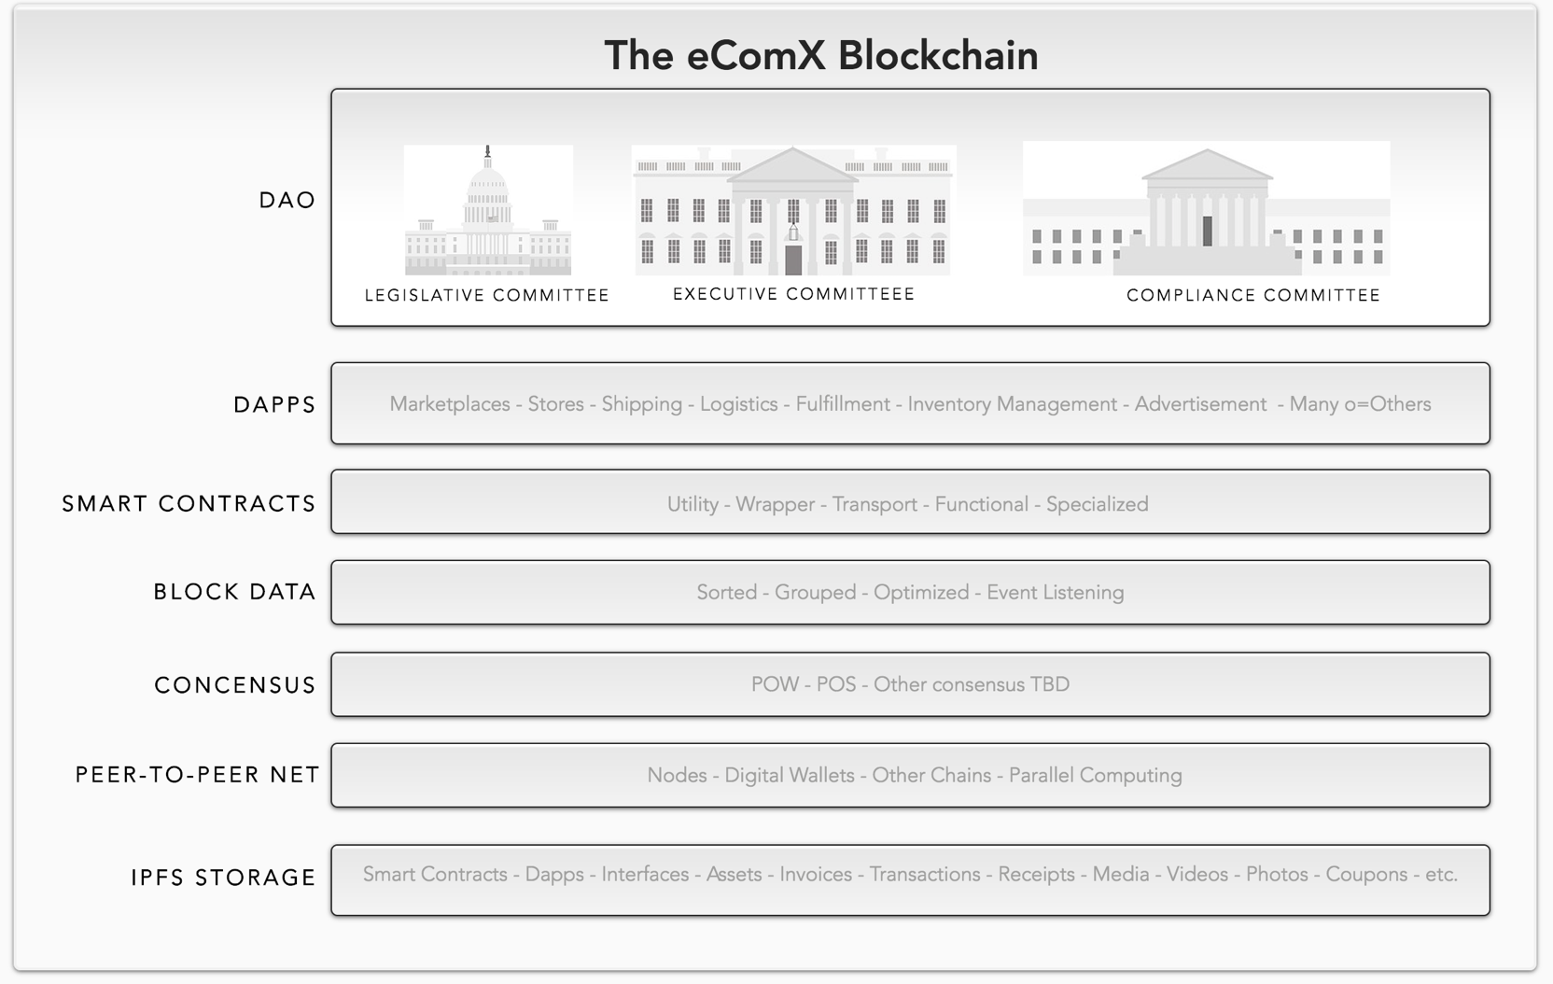

1. The DAO LAYER – Represents the eComX.org functional area where democratic smart contracts for managing the eComX entity hover to support the decentralized, autonomous Organization. Through the DAO is where members interact with the executive, legislative, and compliance committees, its smart contracts afford members a mechanism to nominate and through voting, elect the management team, every 4 years, as it is the case with most democratic organizations. Members can also make proposals and vote on any proposal to be studied or to be implemented by the organization.
2. The DAPPS LAYER – Represents all the decentralized applications running in the eComX blockchain. From eComX native dapps, and from a number of marketplaces, store front services providers, shipping, fulfillment, logistics, and many other organizations, looking to conduct business through the ecommerce blockchain of eComX and to join the Internet of Values.
3. SMART CONTRACTS LAYER – Represents the blood stream of eComX. Here is where the tokenization of centralized assets, the wrapper and transport token ECOMX, the functional smart contracts of eComX, and all other specialized tokens developed by us and/or our partners reside.
4. BLOCK DATA LAYER – Special functionality lives in this area to sort, group, split, and combine transaction requests triggered by events fired from within the tokens that represent them. They are separated into packages that can be consumed by the nodes in the network to perform parallel computing calculations and which perform the execution of code.
5. CONSENSUS LAYER – Here is where the consensus algorithms reside. Proof of Work and Proof of Stake are combined into a Hybrid consensus type in order to ensure the unpredictability of bookkeeping nodes and enhances the security and robustness of the eComX platform by realizing the randomness of the nodes performing parallel computing for eComX. An additional benefit is reached through abstraction in order to achieve better balance between PoW and PoS, to combine the advantages of both, to avoid the centralized trend of computing power or stake, and to achieve a reasonable and stable energy efficiency ratio for parallel computing. Lastly, we seek to dynamically manage the computational power demand by introducing a node-balancing algorithm to harvest additional nodes for the eComX parallel computing machine during peak demand or as the volume of transactions grow. This will guarantee eComX scalability and it will be how eComX solves the current scalability problem in the Internet of Values as it applies to crypto-ecommerce.
6. PEER-TO-PEER NETWORK LAYER – Represents the nodes in the network looking to earn eComX GAS and which are rewarded by eComX for their prompt response to processing of the blocks awaiting computation. It is here where the Dandelion (de)anonymization protocol gateway will be implemented to provide added IP traceability security.
7. IPFS STORAGE LAYER – We will be using IPFS (Inter Planetarium File System) as eComX decentralized file system and will be using a crypto-volt to store all sensitive information which will require the advance knowledge of a private key in order to open individual content stored. That being said, there will be clear separation into two areas within the eComX file system. One PUBLIC and the second PRIVATE.

### **eComX Interoperability solution**

#### **Centralize to Decentralize Communication**

As mentioned before, blockchains are currently islands on a sea with no viable means to connect with their outside centralized world. As most of the tradable assets in the world have a digital representation that exists only in the centralized world, it is of upmost urgency to solve the issue of interoperability and create no just bridges to the decentralized islands represented by blockchain, but actual super-highways as the need to connect the centralized assets to the blockchain is critical for the Internet of Value to come into fruition.

With this in mind, eComX is developing the eComX token, smart token capable of wrapping the asset data structure and transporting it into the eComX blockchain for secured circulation and processing. This approach insures that the ownership signatures of the asset stays with the asset on only the data needed to conduct a successful transaction in the blockchain is transported into the eComX blockchain.

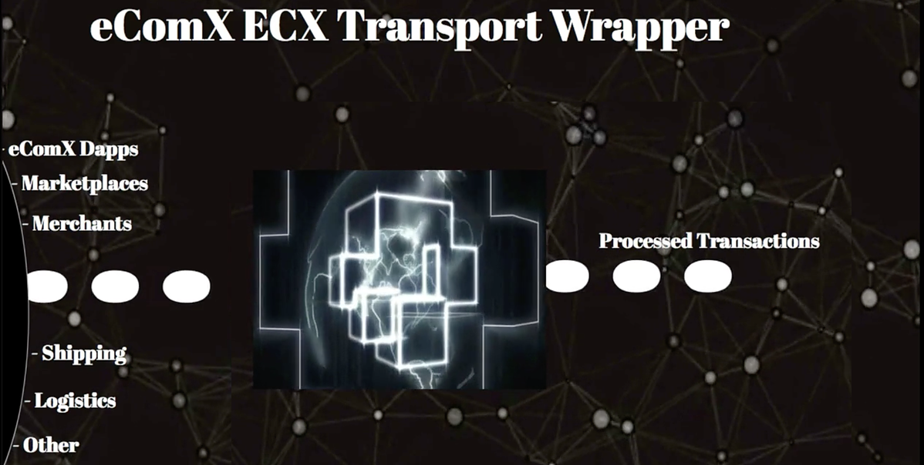

The figure above illustrates how assets or transactions once wrapped by eComX Tokens enter the blockchain to be processed. Once circulating in the blockchain, the eComX token fire events which are listened to by smart contracts and these events in turn are sorted and grouped into blocks by consensus to be executed by eComX parallel computing network of nodes.

To achieve the interaction between different tokens, eComX is fitting its EComX Token with the mechanism to listen for events themselves. This gives elasticity to the tokens as they can be combined into more complex transactions for instance, we could envision a purchase request coming from a marketplace, to be listen to by a shipping token, a logistics token, and an inventory token to create a packaged transaction which in turn can be computed and tracked from the purchasing step to the delivery step.

Smart contracts allow for richer applications across tokens. However, the current smart contracts circulating in a public blockchain today can only handle the same type of objects, similar digital assets, similar currency, etc. At present, the research on cross-chain transactions mainly focuses on the realization of atomic transactions between two different digital assets. Its limitation lies in the fact that it is far from fulfilling the complex application scenarios presented by the Internet of Values of interoperability.

By wrapping different digital assets with EComX Tokens, then transporting them to the blockchain, we solve the interoperability bottleneck and succeed not only on the ability to interact with centralized assets but also in defining complex relationships between these different digital assets in terms of time and space.

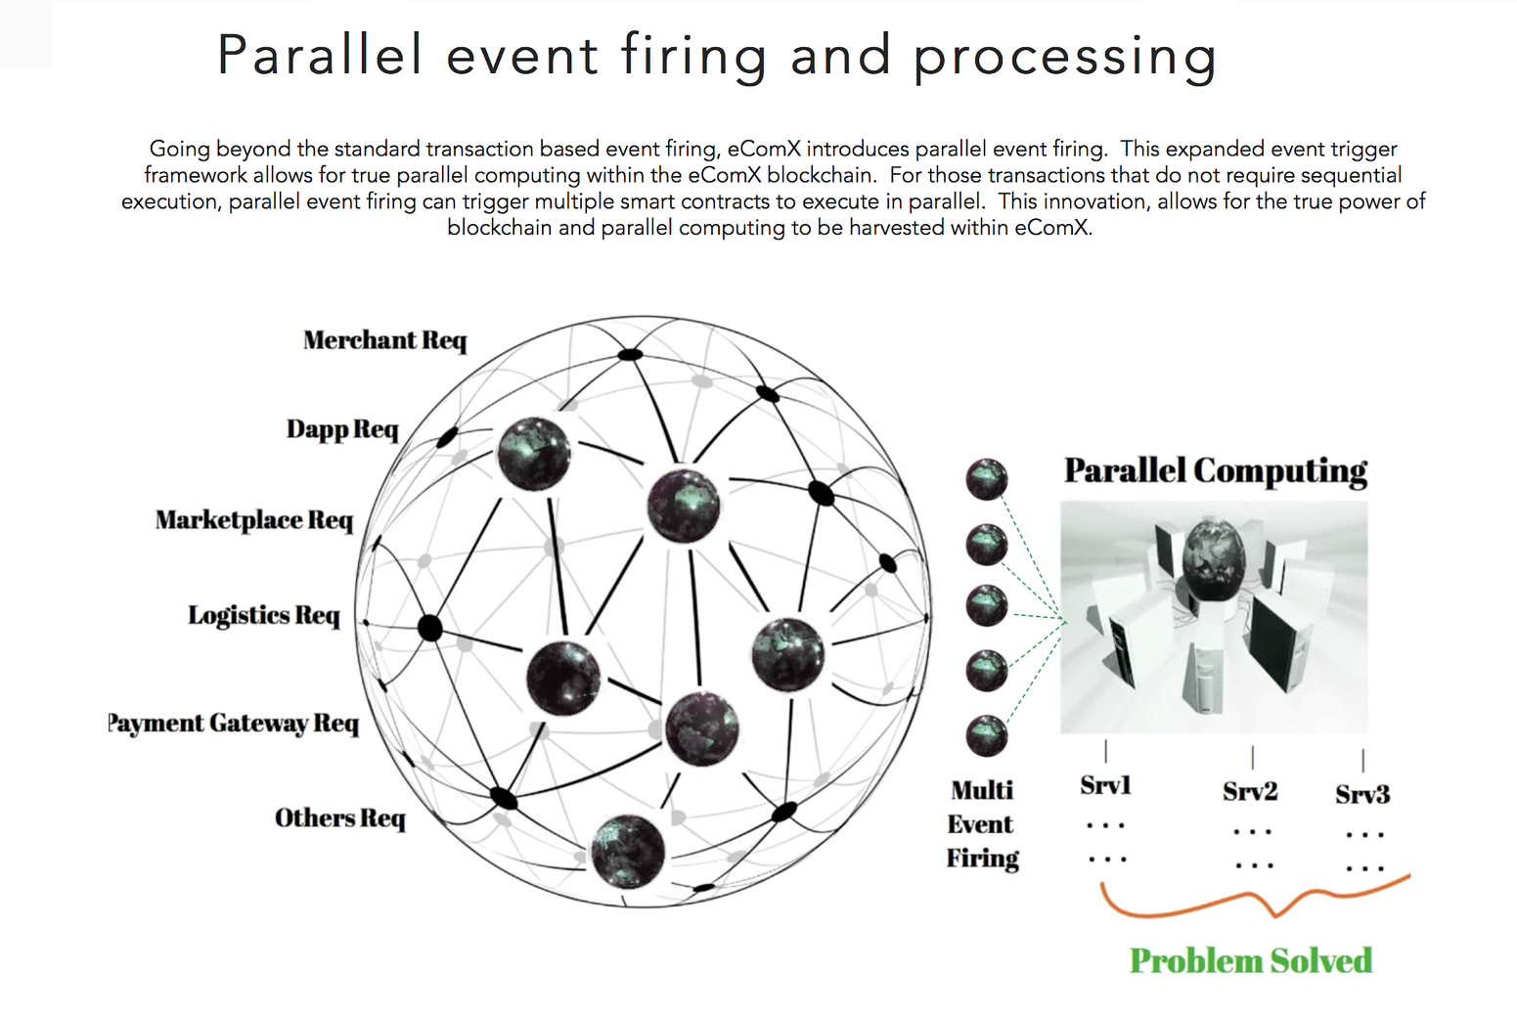

Taking this idea one step further, by expanding the eComX blockchain to fire multiple events in parallel, eComX makes it possible to accomplish parallel computing regardless of how complex or compounded the token becomes through interoperability. This means that in the future, we should expect eComX to have the ability to create more sophisticated channels for conducting ecommerce, specially, when dealing with cross-border-trade as we know it today.

#### **Token to Token Communication**

The ability for EComX tokens to fire events and to listen to events from other EComX tokens means that the interaction among different assets, transactions, and requests is also possible. The ability to group a series of eComX tokens representing for example, a buyer event, a shipping event, a logistic event, an inventory management event, etc. Means that a complete and more complex packaged transaction can be stitched together and executed as a united by a block or blocks under a given consensus mechanism.

For this to go smoothly, eComX must stablish, clearly, the relationships among multiple EComX tokens within their smart contracts. eComX must succeed in separating the usufructs and the ownerships information of the digital assets being wrapped by the EComX Token. In other words, we must be able to use the usufruct part of the asset to conduct a transaction without compromising the ownership of the actual asset until the transaction has been completed through and through.

### **eComX Parallel Computing**

in eComX, the execution of a smart contract is consistent with the way current smart contracts are executed in public blockchains such as Ethereum, that is, it executes in the node’s operating environment (virtual machine). The difference is that the eComX smart contracts include expanded parallel event triggering and can be connected to other smart contracts by the firing and the listening to events mechanism, leading to a chain of events or to the packaging of transactions containing all the necessary supporting steps such as shipping and logistics which without them the ecommerce transaction would fail.

For the eComX blockchain to work as a crypto-ecommerce infrastructure for the ecommerce economy, it must scale to staggering high volumes of transactions need to be successfully processed under time and space constraints. This is where the need for improve computer power comes into play.

Current centralized organizations invest millions on infrastructure and computer servers to try to handle with scalability issues. eComX has a better and more cost-effective option and that is to harness the power of existing computer power already connected to the network and to leverage blockchain technology and the current consensus mechanism for nodes in the network to perform such computations in parallel.

This requires that eComX expands on the current architecture of blockchain technology by the introduction of parallel event firing, sorting, grouping, splitters, and combiners for blocks to be pre-arranged and for nodes in the network to execute them.

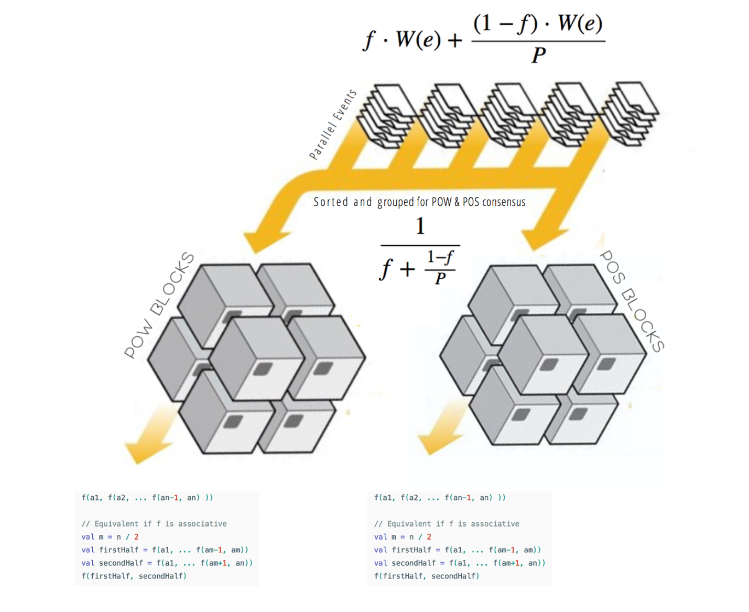

The figure above shows how events are grouped and sorted into packages to be consumed by blocks which are then executed by the nodes in the network.

### **Compatibility with Ethereum**

Initially, eComX smart contracts will be based on Ethereum’s smart contracts. For enhancements such as parallel event firing mechanisms and additional functionality, it will be implemented so that the eComX smart contracts and the Ethereum smart contracts remain compatible. This will allow smart contracts now running on Ethereum to easily migrate to the eComX blockchain in the future and it will enable developers of smart contracts to quickly develop on eComX as well.

eComX will initially use “Golang” and solidity which is the language of Ethereum as its programming language but with time it will also release its on optimized language also as a next evolution to solidity to better leverage the advances reached by eComX.

eComX will leverage the EVM but intends to quickly transition to its own JVM in order to better support Turing-Complete computations in its parallel virtual machine.

### **Software Development tools and software library**

Overtime, eComX intends to provide more intuitive application development tools and debugging environments for developers to use. It also will provide smart contract programming environments and a rich library covering the full spectrum of ecommerce such as marketplaces, shipping, fulfillment, logistics, inventory, etc.

Developers can easily access the eComX software library to achieve the rapid development of smart contracts. We intend to provide a development sandbox for realistic testing before deployment.

As the platform’s underlying functions and common ecommerce fundamental applications become more resourceful and sophisticated, application developers can employ these smart contracts by setting preconditions to realize the intended ecommerce applications.

In order to further improve such a development environment and drastically reduce the development threshold for developers, eComX future plan includes visual and modular application development tools, a compilation environment and an application test environment, which will allow smart contract developers to focus on innovations for the crypto-ecommerce economy and the Internet of Values.

# **eComX Project Plan**

#### **Interfaces to various central organizations and external data**

eComX will provide interfaces for key centralized organizations and external data-sources so that more values and data can be accessed, wrapped and transported to the eComX blockchain.

#### **Continuous development**

The platform will continue to improve and upgrade itself in the aspects of parallel computing, parallel event firing, consensus mechanism, and the platform will be developed into a high-throughput decentralized organization. eComX will continue to reach out to the application market, increase usage of its smart contracts and expand the EComX Token capabilities including the creation of a new family of powerful tokens and interfaces.

It will continue to work with centralized organizations and with academia to continuously promote the standardization movement of the eComX blockchain and to sponsor through collaboration and in some cases through grants, the participation of major research universities around the world to pitch in their contributions and to solve critical problems facing the development of the future of ecommerce and of the Internet of Values.

### **eComX Community Contribution**

Although eComX Corporation is a private company from the United States, the eComX.org DAO is a public organization, and the eComX blockchain when released will be public, ecomX.org exists as a free ecosystem managed by experts voted into their respective roles initially by eComX Corporation and as time goes by, by its members, rather than by corporation. This time-based transition of the DAO is intended to insure it continues to be true to the vision of the founders of eComX. This means that the organization focus on success from its technological achievements first and not to corporate profitability, as traditional enterprise projects do.

The final result of all this effort is to insure eComX.org does not belong to any single organization or individual but that it belongs to the world as we deliver the eComX crypto-ecommerce to the Internet of Values.

eComX invites everyone willing, and capable to contribute to join us in continuing the development of the eComX project. Blockchain projects start with an important need or problem to be solved, which also needs to be constantly explored by participants and those in need, encouraging continual improvements.

The founders of eComX envision it to be an all-inclusive organization and their intention is to attract more people into the community. The goal is for these projects to be community-oriented from the beginning.

### **eComX community members**

* At the DAO level, eComX members are the administrator, and the people tasked with maintaining the organization on course. At this level, lives the different legislative, executive, and compliance committees, as well as other sponsors and facilitators of the project’s platform.
* At the technology level our members are composed by eComX developers, organization’s development teams, and independent contributors to our software library
* Computer Nodes. These are our future miners’ community, they represent the nodes doing the parallel computing for eComX. They eComX token economy driven initially by the eComX Utility token will allow eComX to raise contributions for grants, rewards, and GAS payment for those nodes running our smart contracts and at the same time performing a few administrative tasks for the eComX operations.
* The eComX.world cross-border marketplace, where sellers and buyers can buy-sell-products using fiat or crypto currencies.
* eComX Platform Users. They use the eComX platform for crypto-ecommerce services. These are centralized and decentralized marketplaces, shipping, fulfillment, 3rd-party logistics, inventory management, and marketing organizations.
* eComX Token investors, including private equity firms, early investors, late-stage investors and potential investors.
* Social Media.
* Government agencies.

**The importance of the eComX.org as a DAO**

The purpose of the eComX.org DAO is to mobilize as many participants as possible to organize them in the most effective manner to allow eComX to achieve its core function which is to serve a larger community through the development of a crypto-ecommerce economy based on the Internet of Values.

# **Project Roadmap**

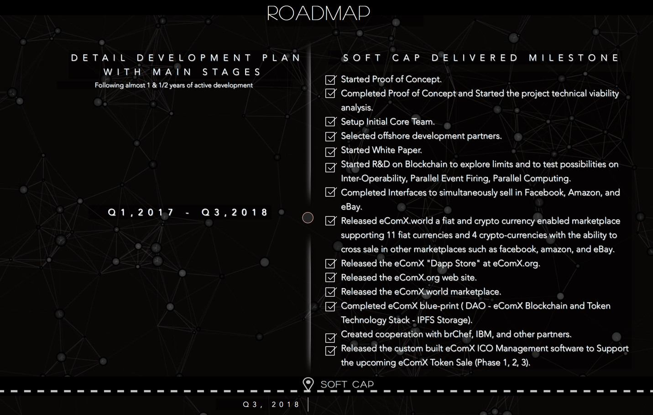

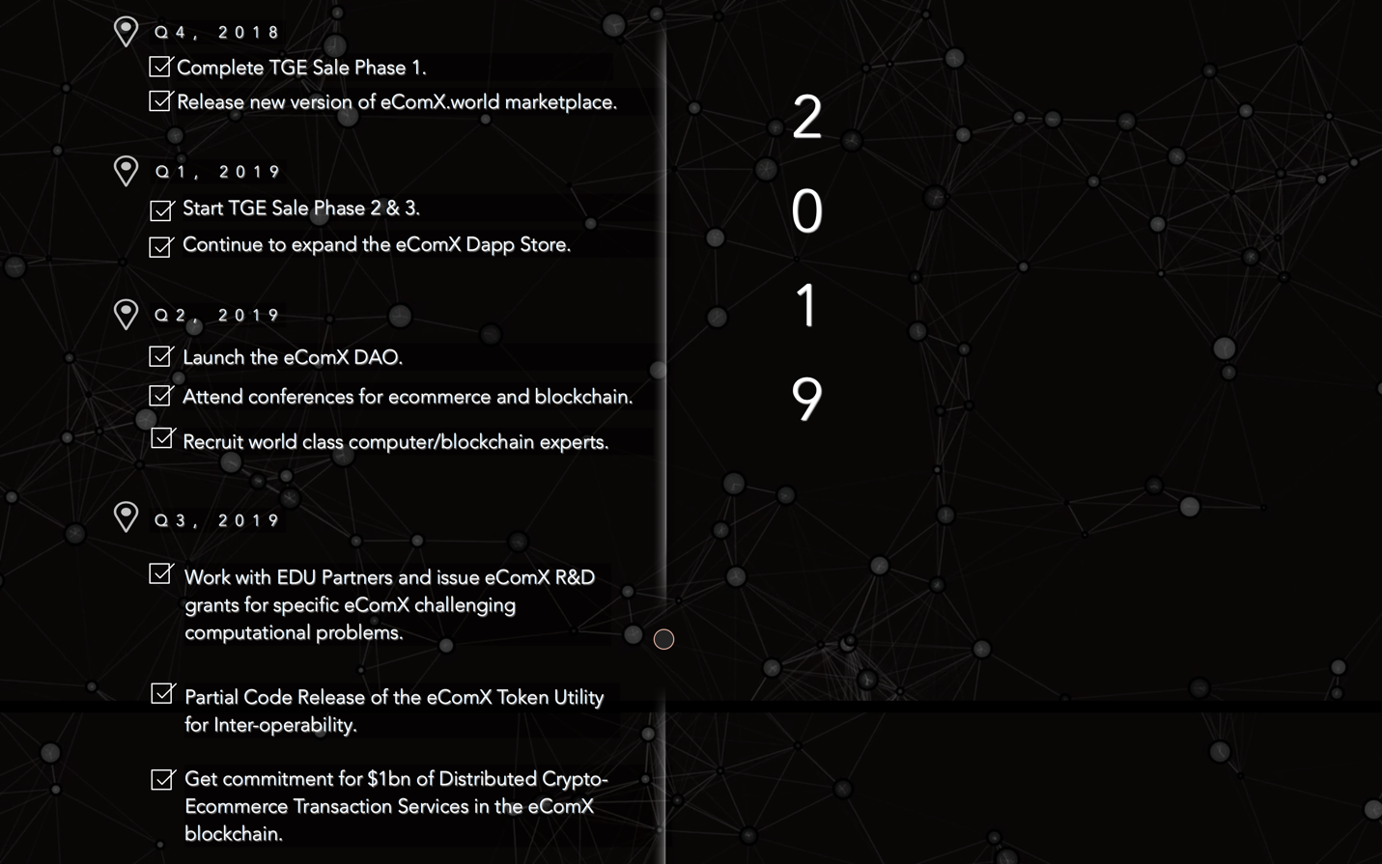

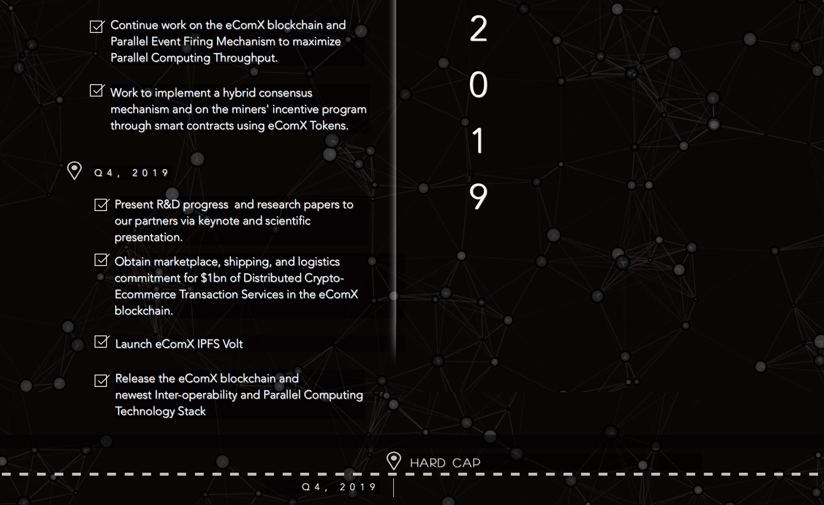

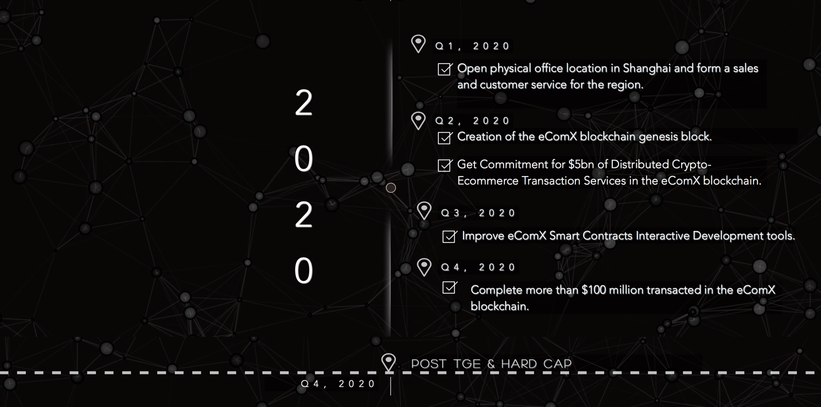

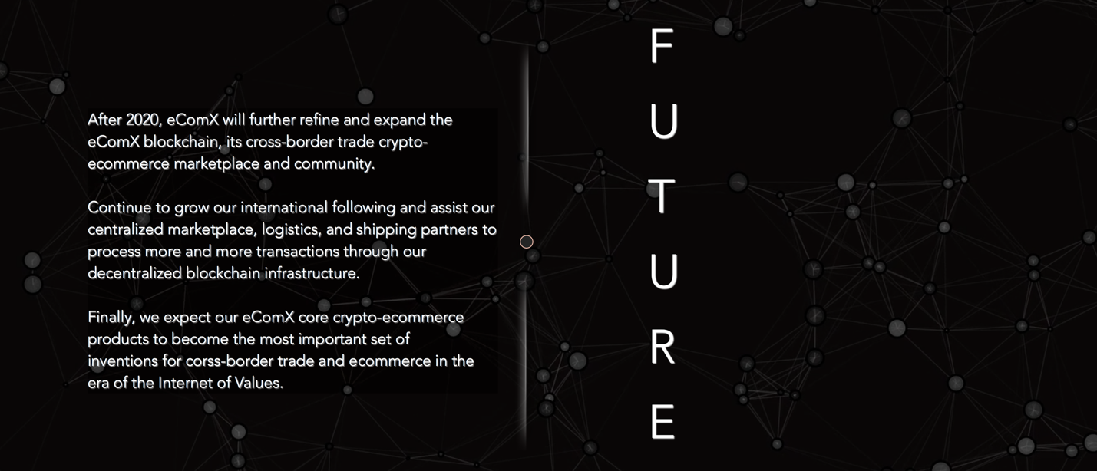

# **eComX Team**

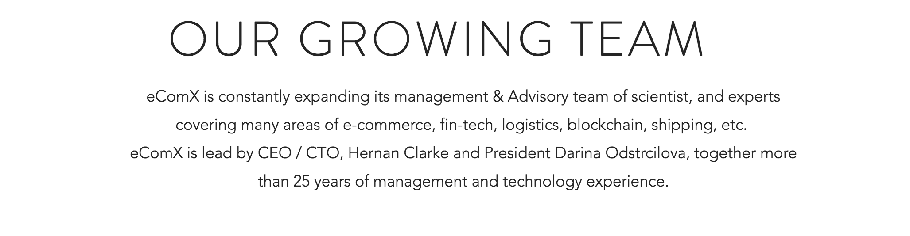











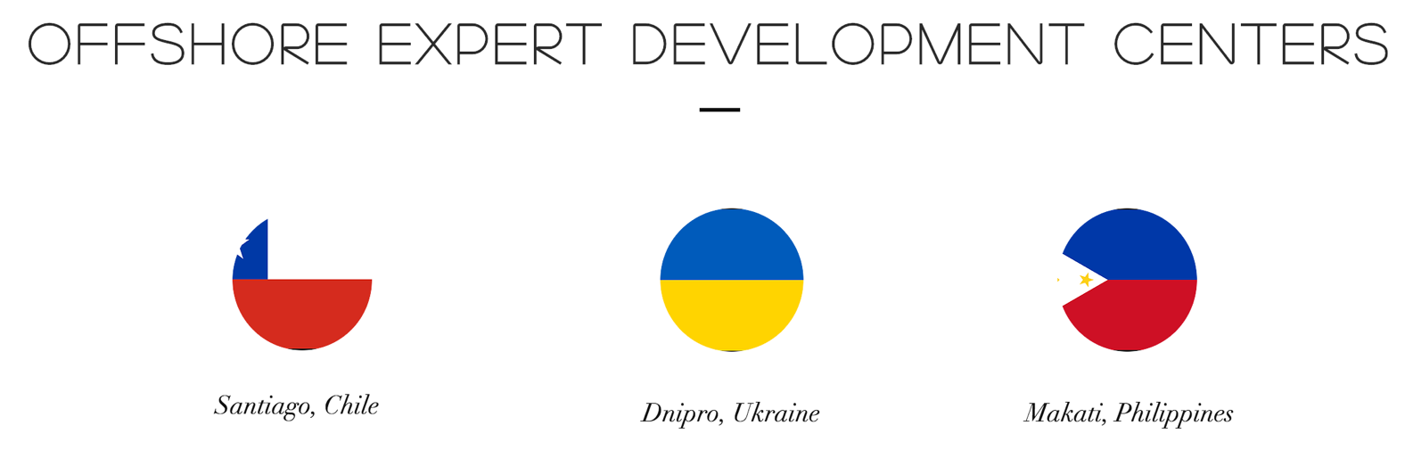

# **Our Growing Community**

You can find eComX on the following communities, user groups, and social media. For the link to each one of our communities please visit [https://www.eComX.org](https://www.ecomx.org/).

[](https://www.ecomx.org/)

# **eComX Products**

### **eComX World Marketplace** [**www.eComX.world**](http://www.eComX.world)

First crypto-ecommerce marketplace where buyers and sellers can transact using fiat or crypto currencies. Through specialty interfaces, eComX World marketplace allows sellers to open a store or bistro in eComX and instantly sell in multiple eComX online galleries, via its Iphone / Android Apps, and in Facebook, Amazon, and eBay. As part of the continue development, eComX will add additional interfaces to other centralized marketplaces such as Mercado Libre, Rakuten, FlipKart, AliExpress…

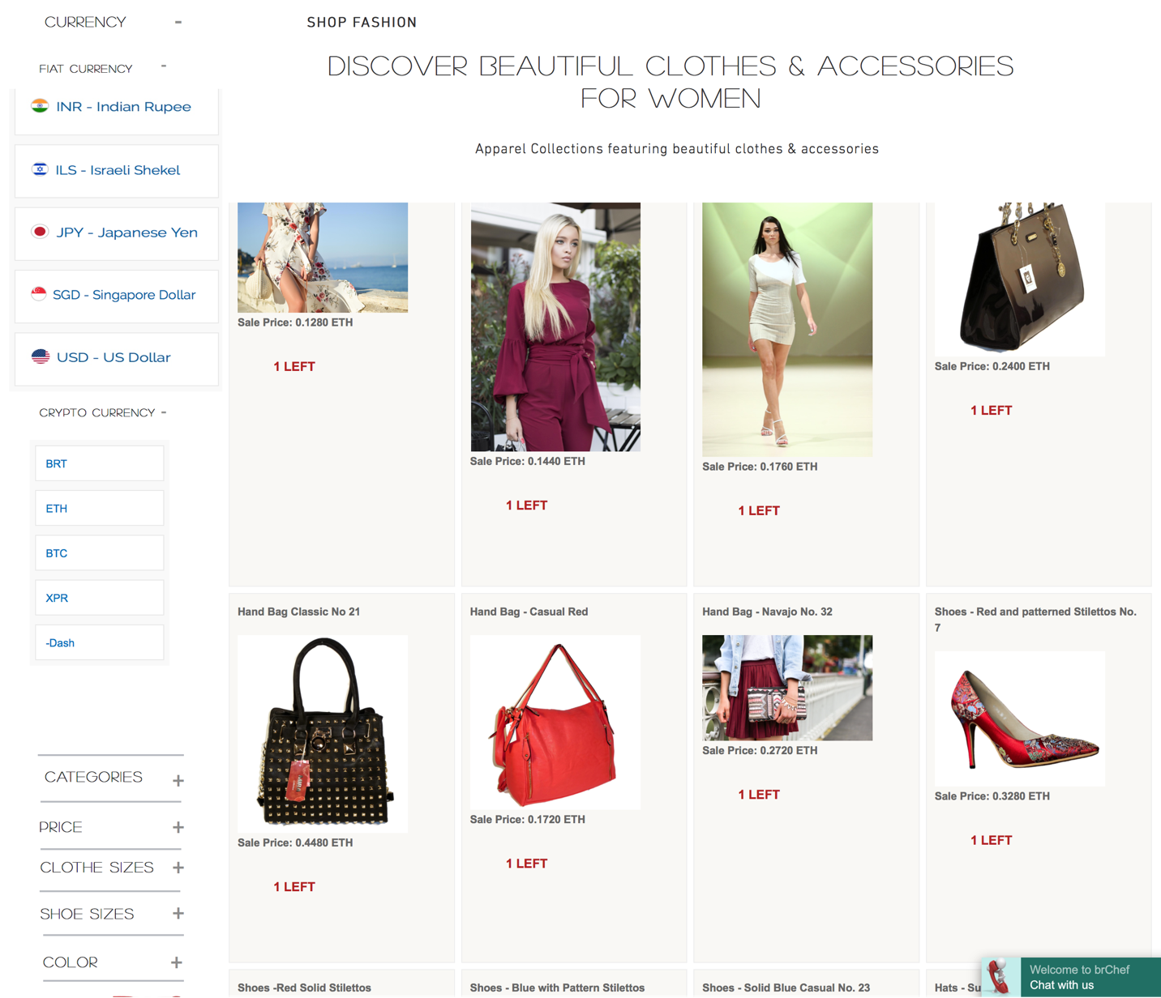

***Figure above - Illustrate Product Listing in Ethereum***

***eComX world supports 11 fiat and 4 crypto currencies***

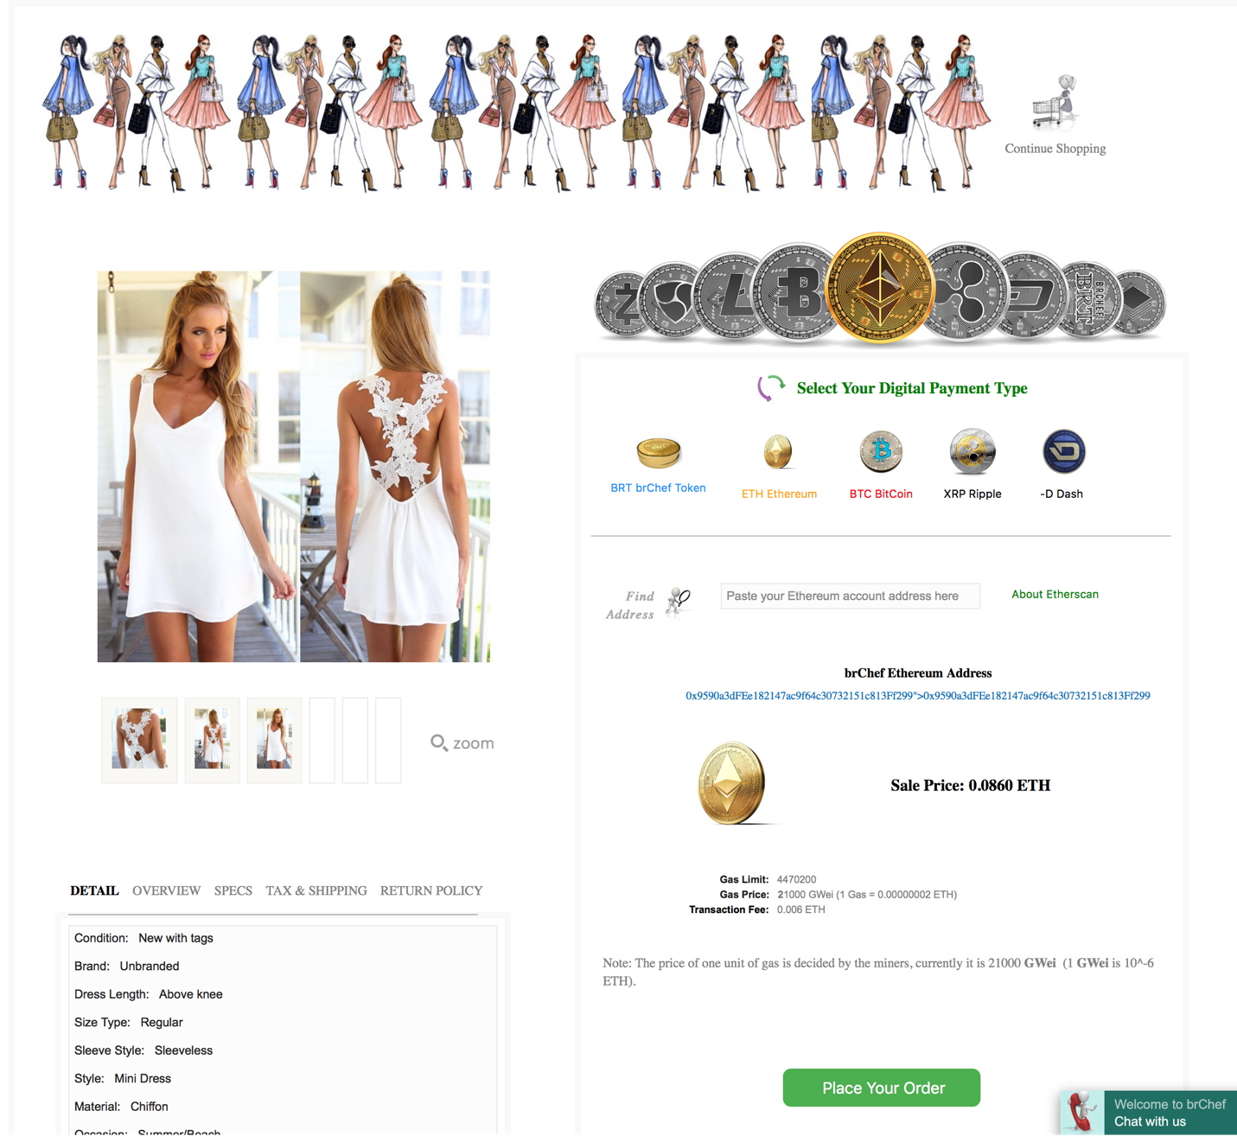

***Figure above – Illustrate a purchase using crypto-currency***

**eComX World Cross Border Marketplace Workflow**

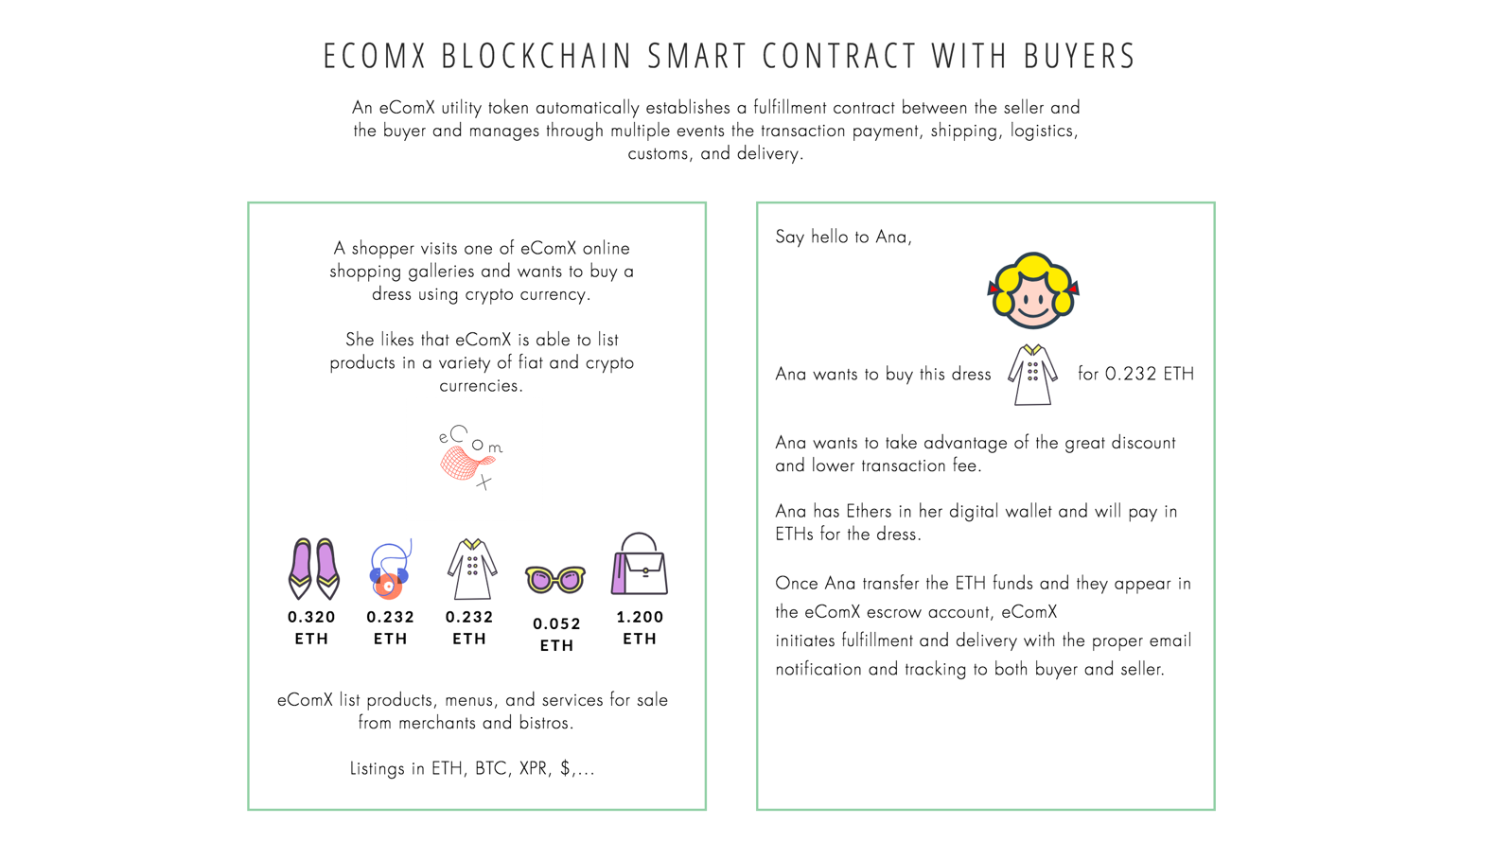

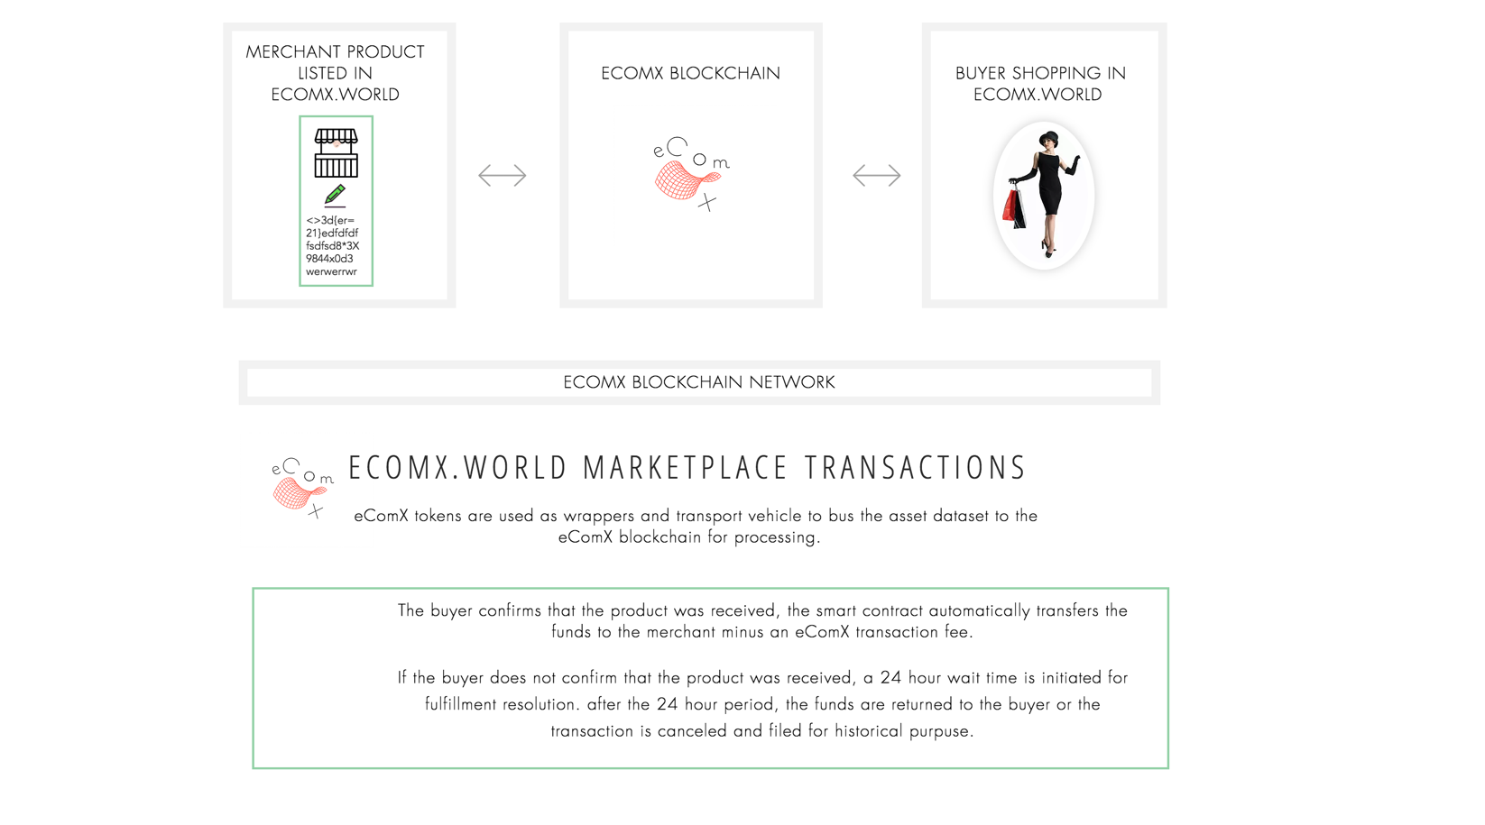

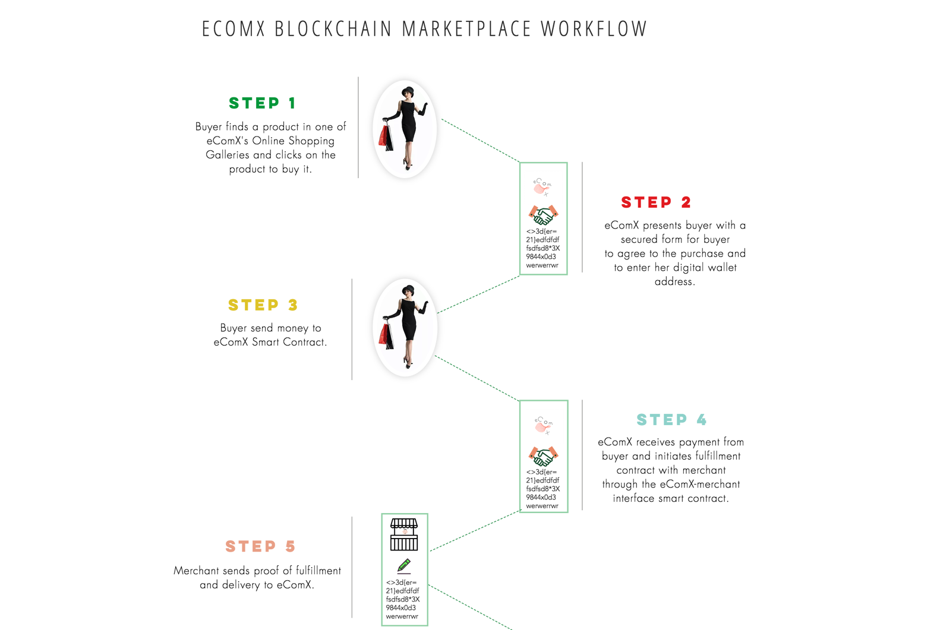

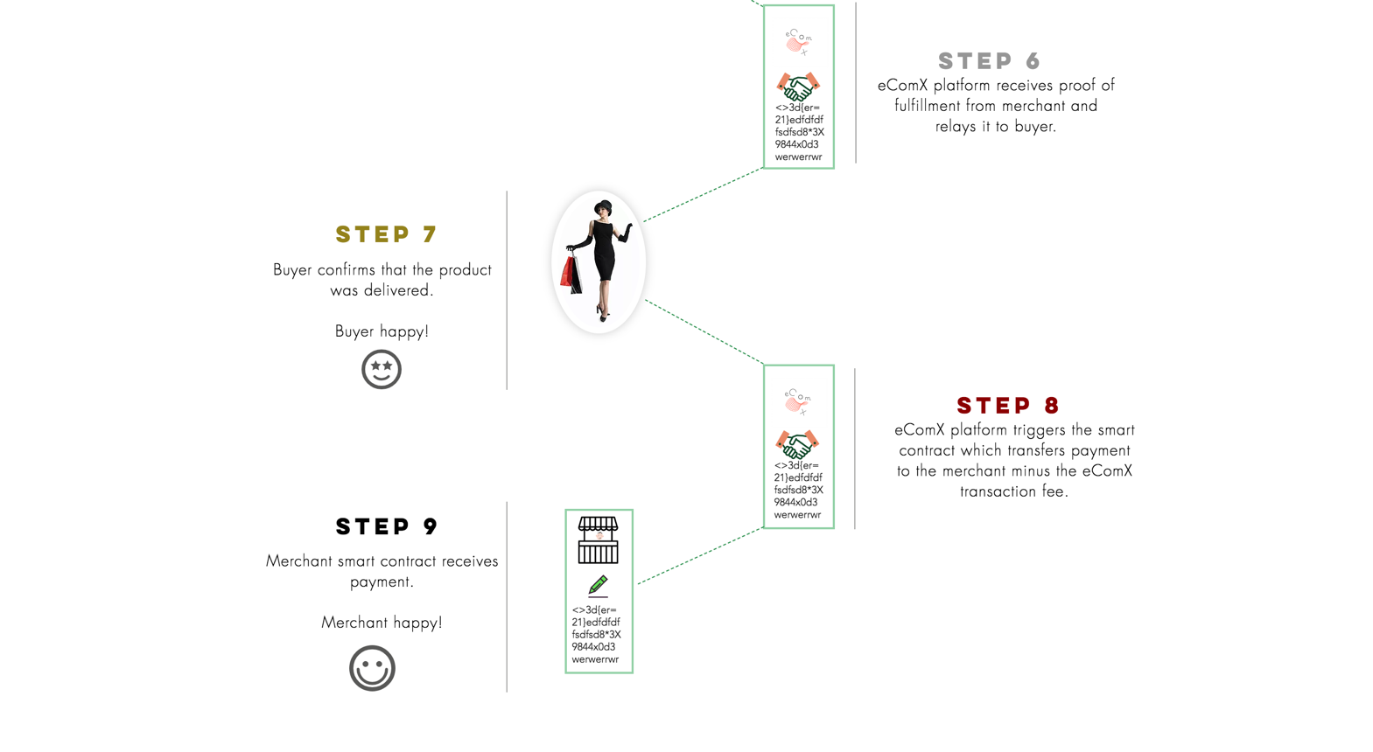

### **eComX Dapp Store**

Home of the ecommerce dapps you love or where to discover a dapp you will soon love.

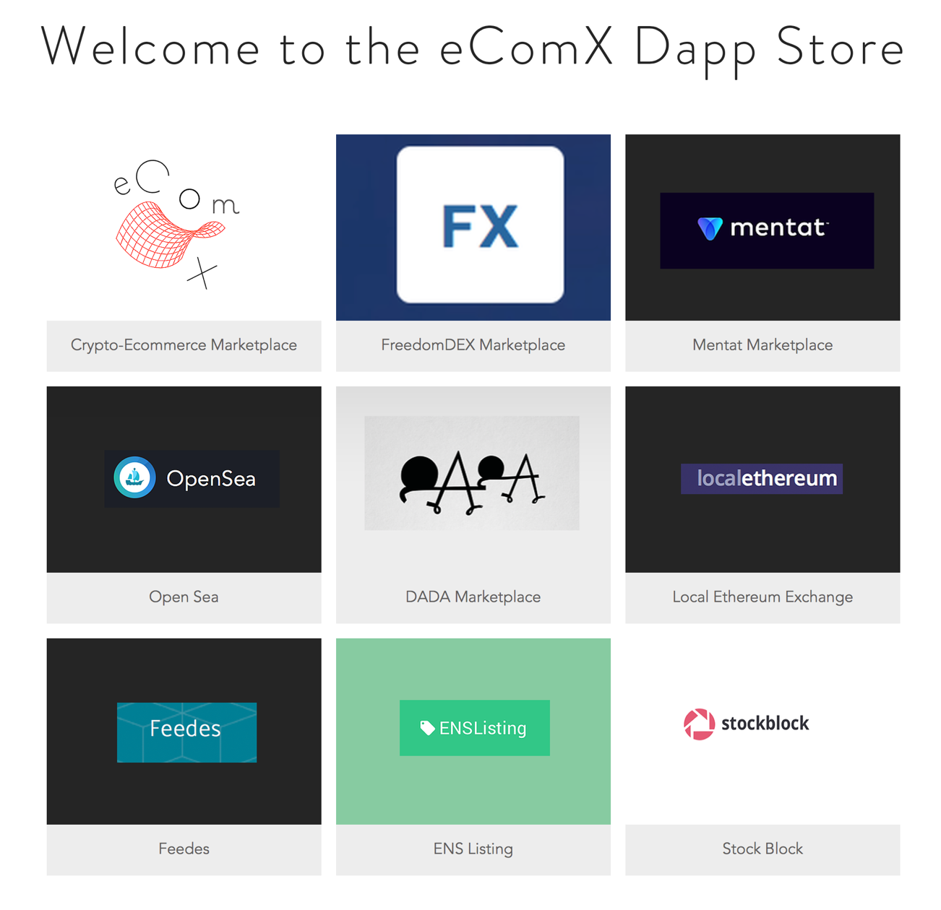

The eComX Dapp Store is already available to our community. To access the “eComX Dapp Store” go to “[https://www.eComX.org/dappstore](https://www.ecomx.org/dappstore)”.

### **eComX Blockchain**

The eComX optimized blockchain for ecommerce with a unique solution to the problem of inter-operability, by using eComX utility tokens to wrap and transport centralized and cross-chain datasets into the blockchain.  eComX is working to addresses the scalability problem with a parallel event firing mechanism and it intends to secure maximum parallel computing throughput, through a hybrid consensus mechanism.

According to our roadmap, eComX plans to release the first working iteration of the eComX blockchain in the 4th quarter 2019.

### **eComX Token**

Tokens are an integral part of the public blockchain ecosystem. It is the incentive mechanism for the economic system of a public blockchain. It is the token-based consensus mechanism that brings community members together to achieve a major undertaking in a blockchain ecosystem. For project creators, tokens are the necessary rewards for them and the motivation for continued participation in the future; for users, tokens are passports; for investors, tokens are tickets to the future; for developers, tokens let them become shareholders; for the bookkeeping nodes, tokens are their hard-earned compensation. All those who hold tokens can have the above multiple identities. They are closely related to public blockchain projects and become users, promoters, developers, investors and in the eComX organization, to grow with the project, creating a great career along-side the inclusive crypto-ecommerce economy and its applications.

The eComX native digital token capable of wrapping and transporting centralized and other chain objects datasets to the eComX blockchain for processing. Also, it is able to listen for and connect with other events via its event handling mechanism for (logistics, shipping, cross-border customs declaration, etc.). This allows the token to combine into a complete transaction package for end-to-end fulfillment.

In order to realize the vision of the inclusive crypto-ecommerce platform, the eComX project has designed the utility token (ECOMX) and designed the eComX distribution structure to make the project sustainable.

Number. The total number of tokens is 200 million. This quantity will enable the token to come online at a reasonable contribution amount.

Token distribution. The distribution of tokens is intended to allow the organization to foster project growth, especially to solve the issue of interoperability and scalability.

**Tokens for miners’ fuel consumption**. A variety of transactions (purchases, shipping, logistics, customs, fulfillment) will enter the eComX blockchain through the eComX token wrapping and transporting mechanism. The eComX blockchain needs a large number of distributed nodes to fulfill its vision of optimum parallel computing. The more nodes there are the more secure and agile the chain becomes. The greater the number of transactions running on the chain, the more nodes will be needed. To maintain the number of nodes and power of calculation, the chain needs to reward miners by issuing attractive services’ fees.

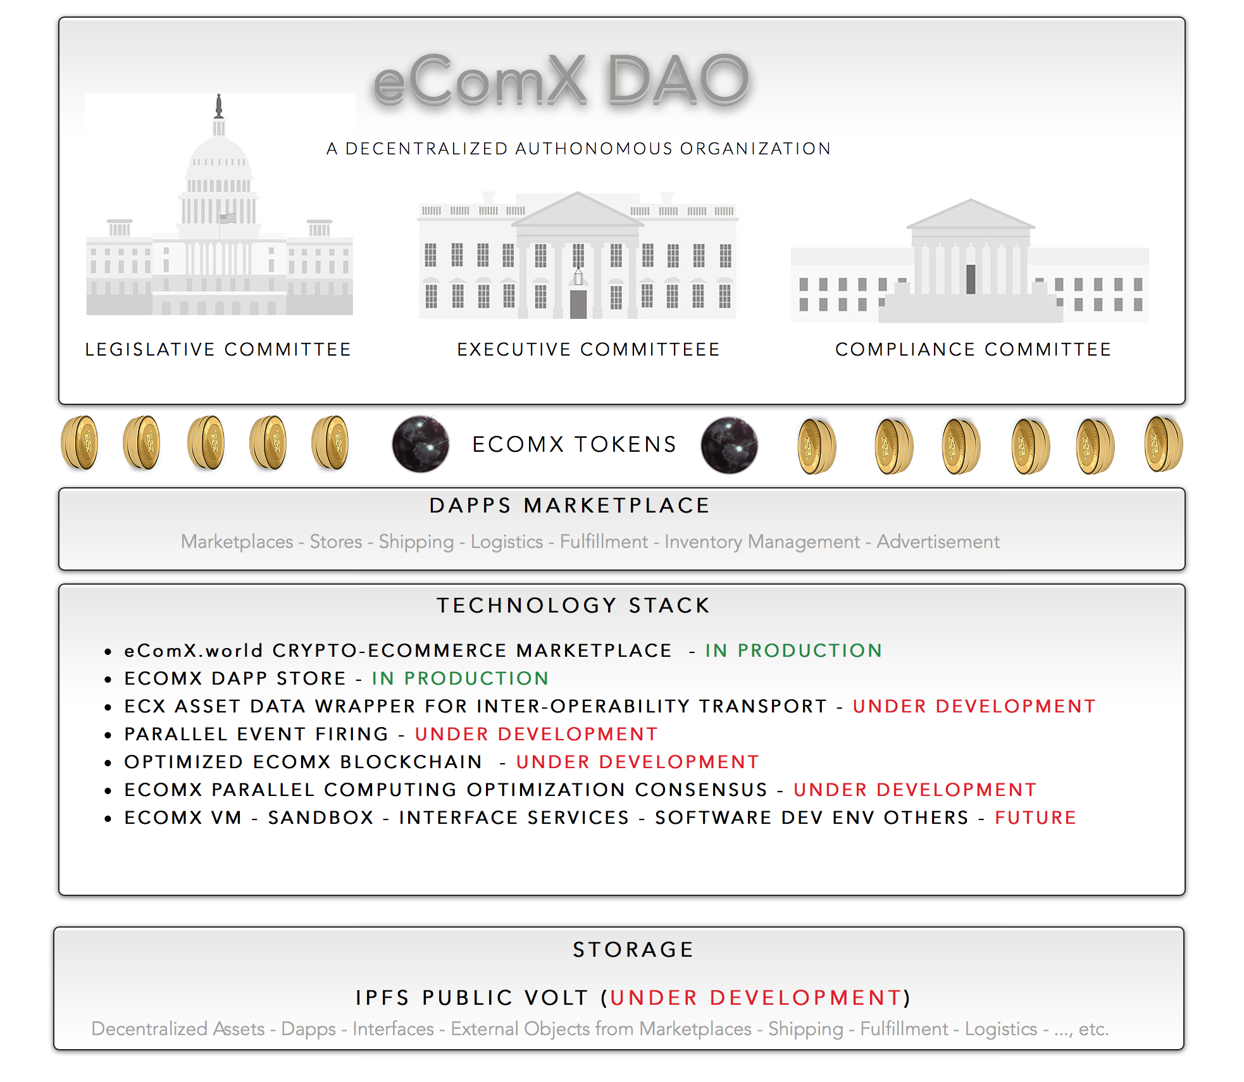

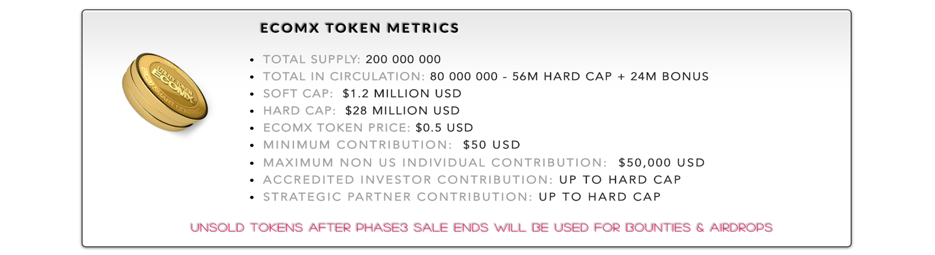

eComX has met its Soft Cap using earlier investments from founders, friends, and family and has completed the project Structure, whitepaper, released the Fiat and Crypto Ecommerce Marketplace, [www.eComX.world](http://www.eComX.world), and it has released of the eComX “Dapp Store”, along with several other milestones.

eComX is now preparing to enter into a pre-sale and a three-phase eComX Token Sale through a TGE to seek further funding to complete the project, the distribution of both tokens and the “Use of Funds” are explained in the next several pages.

# **eComX Token Distribution**

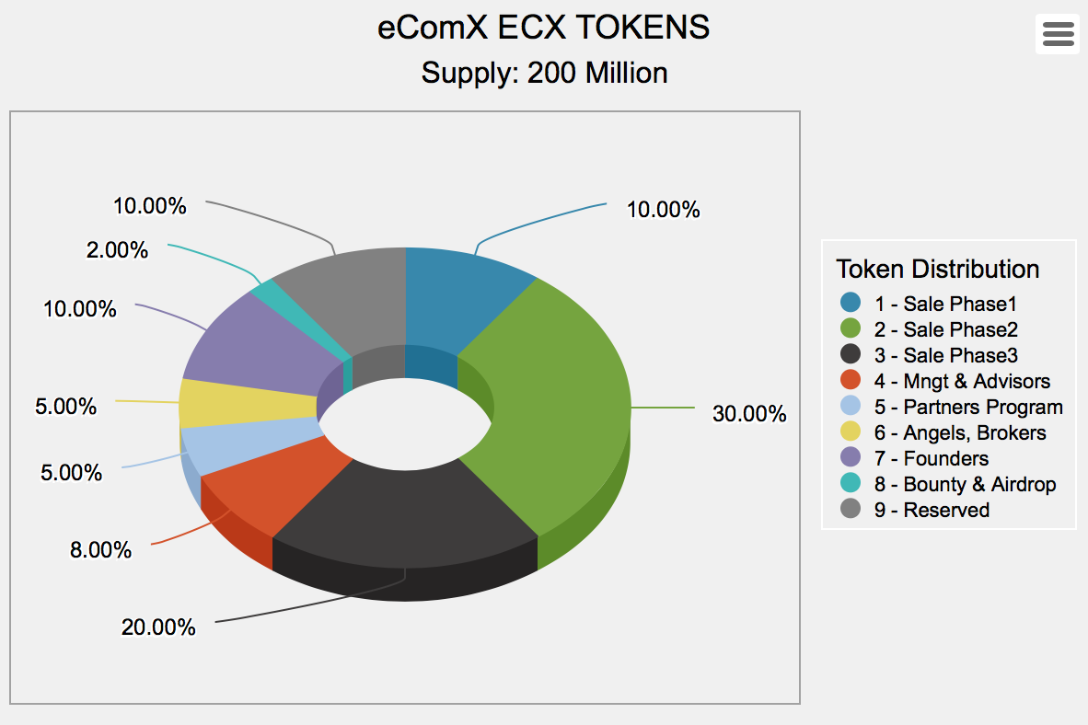

### TOKEN SALE - PHASE 1

10% (20,000,000) tokens are reserved for the eComX token sale phase 2. It will be subject to a minimum transaction of $25,000 for Accredited Investors and $50.00 for NON-US Individuals.

### TOKEN SALE - PHASE 2

30% (60,000,000) tokens are reserved for the eComX token sale phase 2. It will be subject to a minimum transaction of $25,000 for Accredited Investors and $50.00 for NON-US Individuals.

### TOKEN SALE - PHASE 3

20% (40,000,000) tokens are reserved for the eComX token sale phase 3. It will be subject to a minimum transaction of $25,000 for Accredited Investors and $50.00 for NON-US Individuals.

### MANAGEMENT AND ADVISORS RESERVES

8% (16,000,000) of the eComX token supply will be distributed to various advisory firms and individual advisors and management team members, who have helped with their inputs, expertise, and the conceptualization and implementation of the eComX platform. These tokens will be dispersed based on a 16-month vesting schedule with 1 million tokens released every month and divided equally by the number of Advisors and Senior Managers listed. The distribution will start 1 month after the private and public sale ends.

### PARTNERS PROGRAM

5% (10,000,000) of the eComX token supply will be reserved to develop eComX Partners Program to include major marketplaces, shipping, logistics, etc.

### ANGELS & BROKERS (SPONSORS’ PROGRAM)

5% (10,000,000) of the eComX token supply will be reserved to develop a community of accredited angel investors, early adopters, and brokers/agents critical for the funding needed to fully develop the project.

### BOUNTY and AIRDROP RESERVES

ecomX will set aside 2% (4,000,000) of the token supply for a general bounty and airdrop program. The bounty/airdrop program will be open to everyone and will be awarded by eComX as tokens of appreciation for having done or participated on a program that enhances the eComX user community.

### FOUNDERS

eComX’s founders will be entitled to 10% (20,000,000) of the eComX token supply. Theses tokens will be subject to a 12-month vesting schedule.

### RESERVED FOR MINERS REWARD PROGRAM

eComX is reserving 10% (20,000,000) of the eComX token supply. Theses tokens will be Reserve to cover the GAS for miners of the blockchain transactions.

# **ECOMX USE OF FUNDS**

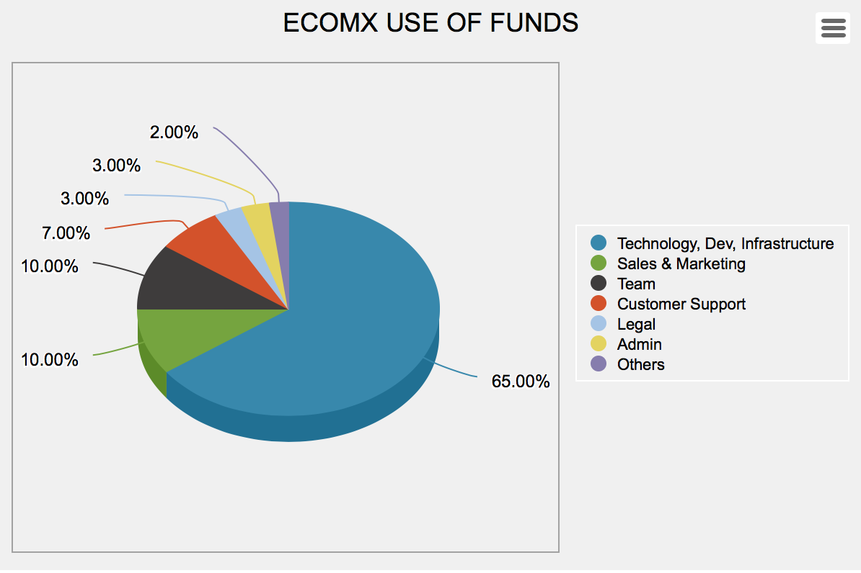

### TECHNOLOGY, SOFTWARE DEVELOPMENT, INFRASTRUCTURE

Refers to the cost of building or acquiring core technology, building and maintaining the eComX blockchain including GAS payment to miners initially in the Ethereum blockchain and later for the eComX blockchain, VM, the eComX token, smart contracts, Dapps, etc. including but not limited to server costs, and development tools, consultants, grants to our EDU partners for specific R&D Projects, and Equipment.

### SALES & MARKETING

Refers to the cost of communicating and delivering the organization’s value to its users and partners, such as general outreach through various channels, public relations, media coverage, community building/management, and advertising. Including Sales and Ambassador’s Team and Consultants.

### TEAM

Refers to the cost of assembling a core of world best scientists, PHD Fellows, Engineers, and blockchain experts to lead and manage the development of the crypto-ecommerce technology.

### CUSTOMER SUPPORT

Refers to the cost of assembling a core of support specialists with deep knowledge of the eComX multiple areas to which the public may need assistance with.

### LEGAL

Refers to the organization’s ongoing legal expenses, due to organization setup, and any and all legal advice.

### ECOMX DAO ADMINISTRATION

Refers to the cost of operating the DAO organization including building rent, consultant fees, depreciation on office equipment, supplies, subscriptions and utilities, as well as managerial compensation.

### OTHERS

Refers to incidental and other miscellaneous expenses which cannot be classified such as travel, lodging, and attending conferences, others.

We invite you to share on the vision of eComX and to join us in the eComX project to create a true transformational platform for the future of eCommerce. We believe that eComX will be at the center of the next eCommerce revolution.

# **DECLARATION**

**This document is a technical whitepaper to be used for information purposes only. This paper is not a statement of future intent.**

**U.S. citizens, and US residents who are not “Accredited Investor” according to Regulation D of the United States Security and Exchange Commission, are excluded from purchasing eComX tokens in all phases of the token distribution!**

**The eComX TGE Sale website requires all Accredited Investors to be certified by a 3rd party service and after such certification is uploaded to our servers and properly reviewed, the sale to such accredited investor can be changed from “ verification” to “verified” and then the accredited investor can participate in the token distribution as stated in the eComX token sale “**[**Terms & Conditions**](https://www.ecomx.org/Documents.html)**”.**

**It is important to re-state that the eComX tokens themselves are not securities, commodities, swaps on either securities or commodities, or similar financial instruments. The eComX Tokens are not designed for investment or speculative purposes and should not be considered as a type of investment. Nevertheless, U.S. citizens, residents and non-accredited investors or entities should not purchase or attempt to purchase eComX Tokens.**

**eComX developers has gone through great care to design the TGE software to keep individual US Citizens and other unauthorized persons from purchasing EComX Tokens and to require accredited investors to get verified by our partner: EarlyIQ (** [**https://www.earlyiq.com**](https://www.earlyiq.com) **) and to pass a comprehensive KYC / AML verification managed by our KYC Partner: IdentityMindGlobal (** [**https://identitymindglobal.com**](https://identitymindglobal.com) **).**

**The eComX token distribution contract, the eComX token smart contract, the eComX blockchain, the eComX.org web site and its cross-border crypto-marketplace www.eComX.world are being provided on an “as is” and “as available” basis without representations, warranties, promises or guarantees whatsoever of any kind made by eComX. Prior to purchasing eComX tokens, you should ensure that you carry out your own examination and investigation and carefully review in the entirety the risks associated with purchasing eComX tokens as set forth in the eComX tokens Sale Terms & Conditions document. Purchases of eComX tokens are non-refundable and purchases cannot be cancelled. Under no circumstances will you be entitled to receive money or compensation for any EComX Token purchased or your inability to purchase eComX tokens. The eComX tokens do not have any other rights, uses, purpose, attributes, functionalities or features, express or implied beyond those specified in this document.**

**This paper may not be redistributed, reproduced or passed on to any other person or published, in part or in whole, for any purpose, without the prior, written consent of eComX Corporation. Or unless the distribution is made by one of our partners, agents, or brokers which have entered into such agreement with eComX and who has entered into an NDA agreement with eComX. The manner of distributing this paper may be restricted by law or regulation in certain countries. Any disputes will be handled by the rules of Arbitration in a court with Jurisdiction in the United States and all applicable law will be that of the United States.**

**EComX tokens are issued and sold by eComX Corporation., a US Corporation in good standing and with headquarters at: 99 Wall Street, # 1000, New York, NY 10005. Persons into whose possession this paper may come are required to inform themselves about and to observe such restrictions. By accessing this paper, a recipient hereof agrees to be bound by the foregoing limitations.**

# **DISCLAIMER**

This eComX whitepaper is for information purposes only. eComX.org does not guarantee the accuracy of or the conclusions reached in this whitepaper, and this whitepaper is provided “as is”. eComX.org does not make and expressly disclaims all representations and warranties, expressed, whether explicit or implied, statutory or otherwise, including, but not limited to: (i) that the contents of this whitepaper are free from error; (ii) that such contents will not infringe third-party rights; and (iii) warranties of fitness for a particular purpose, suitability or function. eComX Organization and its affiliates shall have no liability for damages of any kind arising out of the use, reference to, or reliance on this whitepaper or any of the content contained herein, even if advised of the possibility of such damages. In no event will eComX.org or its affiliates be liable to any person or entity for any damages, losses, liabilities, costs or expenses of any kind, whether direct or indirect, con-sequential, compensatory, incidental, actual, exemplary, punitive or special for the use of, reference to, or reliance on this whitepaper or any of the content contained herein, including, without limitation, any loss of business, revenues, profits, data, use, goodwill or other intangible losses.

The contents of this paper and the eComX project could be subject to change, so please subscribe to e-mail updates on our website to be notified of any changes. Unless expressly specified otherwise, the products and innovations set out in this paper are currently under development and are not currently in deployment. eComX makes no warranties or representations as to the successful development or implementation of such technologies and innovations, or achievement of any other activities noted in the paper, and disclaims any warranties implied by law or otherwise, to the extent permitted by law. No person is entitled to rely on the contents of this paper or any inferences drawn from it, including in relation to any interactions with eComX or the technologies mentioned in this paper. eComX disclaims all liability for any loss or damage of whatsoever kind (whether foreseeable or not) which may arise from any person acting on any information and opinions relating to eComX contained in this paper or any information which is made available in connection with any further enquiries, notwithstanding any negligence, default or lack of care.

Some reference and information contained in this publication is derived from data obtained from sources believed by eComX to be reliable and is given in good faith, but no warranties or guarantees, representations are made by eComX with regard to the accuracy, completeness or suitability of the information presented. It should not be relied upon, and shall not confer rights or remedies upon, you or any of your employees, creditors, holders of securities or other equity holders or any other person. Any opinions expressed reflect the current judgment of the authors of this paper and do not necessarily represent the opinion of eComX. eComX does not have an obligation to amend, modify or update this paper or to otherwise notify a reader or recipient thereof in the event that any matter stated herein, or any opinion, projection, forecast or estimate set forth herein, changes or subsequently becomes inaccurate. eComX Corporation., its directors, employees, contractors and representatives do not have any responsibility or liability to any person or recipient (whether by reason of negligence, negligent misstatement or otherwise) arising from any statement, opinion or information, expressed or implied, arising out of, contained in or derived from or omission from this paper.

Each recipient is to rely solely on its own knowledge, investigation, judgment and assessment of the matters which are the subject of this report and any information which is made available in connection with any further enquiries and to satisfy itself as to the accuracy and completeness of such matters. Any contribution made to eComX during the TGE period (Phase 1, 2, 3) as described herein is qualified as a non-refundable donation and the contributor waives the right to participate in a class action lawsuit or a class wide arbitration against any entity or individual involved with the contribution to eComX, with the allocation of eComX tokens and with the operation of the eComX Organization.

Whilst every effort is made to ensure that statements of facts made in this paper are accurate, all estimates, projections, forecasts, prospects, expressions of opinion and other subjective judgments contained in this paper are based on assumptions considered to be reasonable as of the date of the document in which they are contained and must not be construed as a representation that the matters referred to therein will occur. Any plans, projections or forecasts mentioned in this paper may not be achieved due to multiple risk factors including without limitation defects in technology developments, legal or regulatory exposure, market volatility, sector volatility, corporate actions, or the unavailability of complete and accurate information.